**Phase 1 Documentation**

Power BI

# 1. Financial Data Sources

In this section, we will identify current available financial data sources in the market and detail popular trading platforms.

The summarized table can be found here: [Financial Data Sources](https://docs.google.com/document/d/1vWM2fENB9DM9kkxrWEezCtNUYORDbF-cPXrcmuTVb7w/edit#)

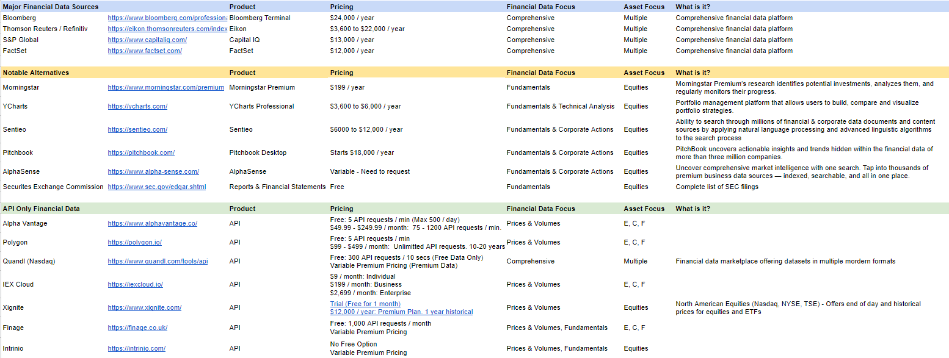

# 

# 2. Dashboard Configuration

## 2.1 Design Thinking for Dashboard Visualisation

### Customer Survey

We conducted a survey to understand the needs of today’s consumers. The survey targeted active traders (i.e. traders who have a fundamental understanding of trading and currently have a portfolio).

The survey results showed that our customers have a varied portfolio from stocks and bonds to cryptocurrency. Mostly within the Singapore and US markets.

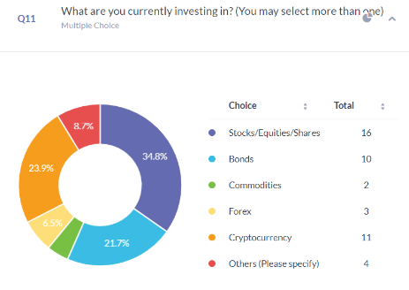

Our customers currently use the previously identified popular trading platforms, mainly Tiger Brokers and Saxo.

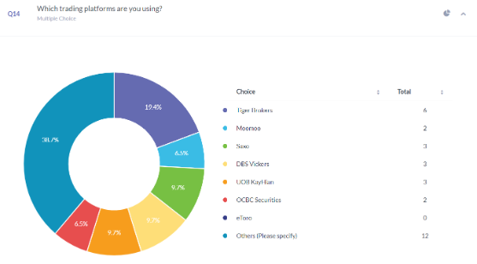

Binance was the most popular cryptocurrency trading platform followed by coinbase.

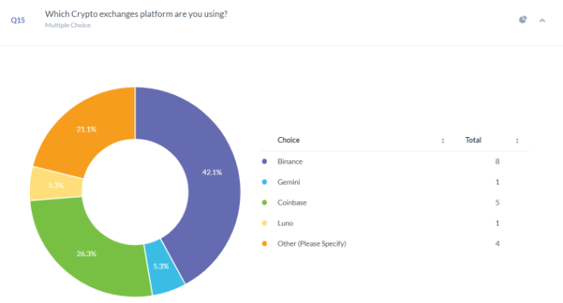

In our survey, we asked our target audience to identify and rank the different possible dashboard features, and the most popular feature is ranked as follows:

1. Portfolio breakdown
2. Individualised performance
3. List of top performing stocks
4. Portfolio recommendation
5. Unrealized performance
6. Key investment indicators such as Alpha and Beta

## 2.2 Sample Dashboards

In this section, the team identified the different trading platforms available and took screenshots of the overview page to give a sense of what users are looking for in an ideal dashboard.

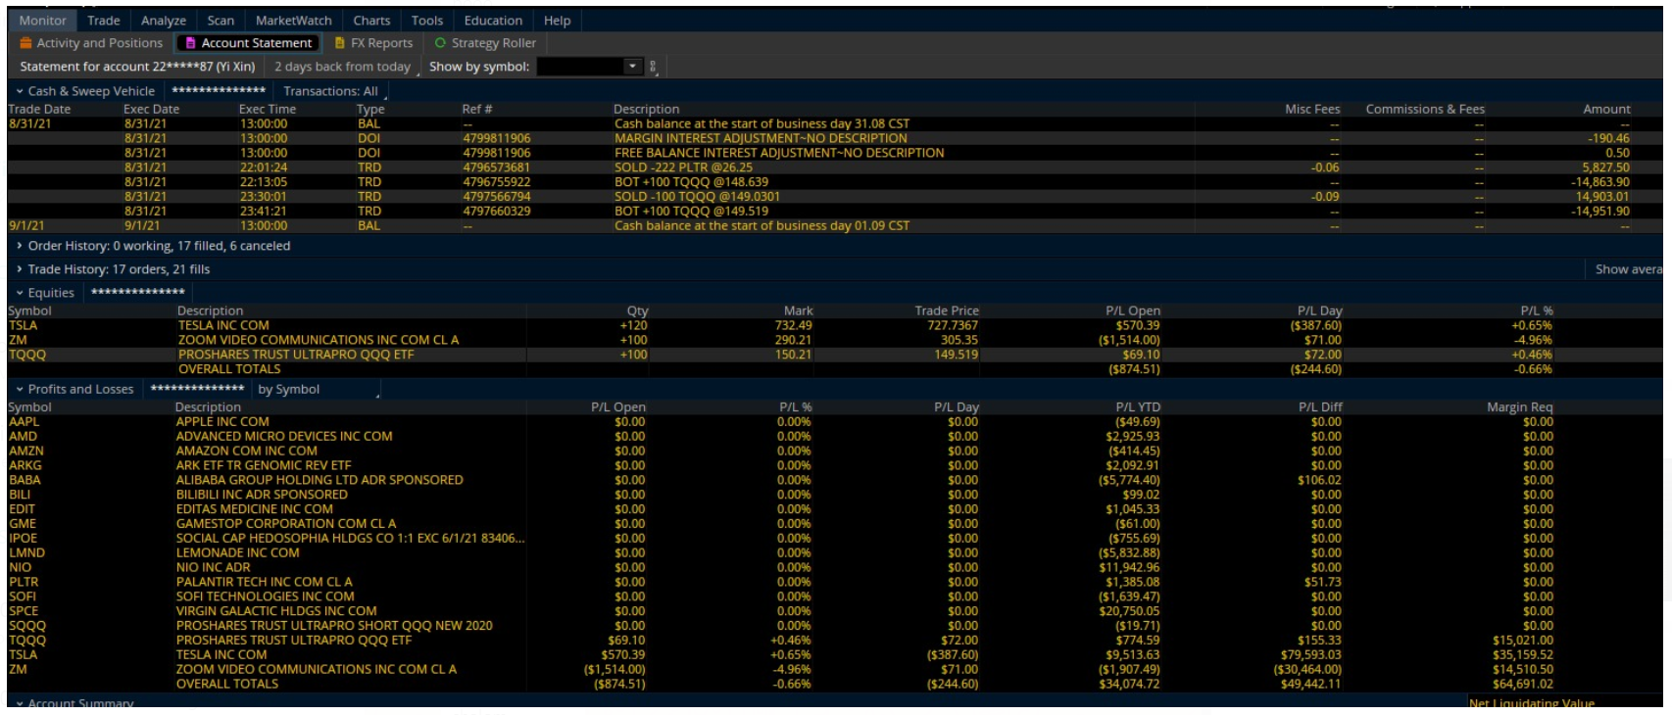

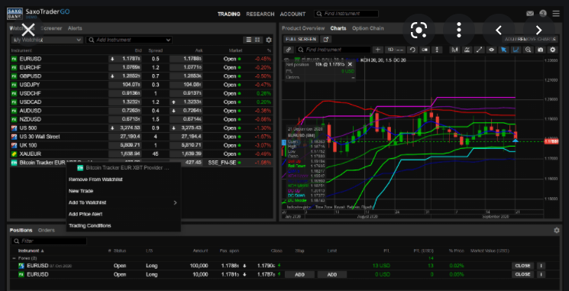

## 2.3 Proposed Visualized Dashboard

The team then used mural to create an idealized dashboard.   
<https://app.mural.co/t/project5b4963/m/project5b4963/1629391387795/0db7b6c99f5030f94d42edea7d354a8e3f981b24?sender=bb9a7fa3-2511-4f42-bb75-32e7740662ec>

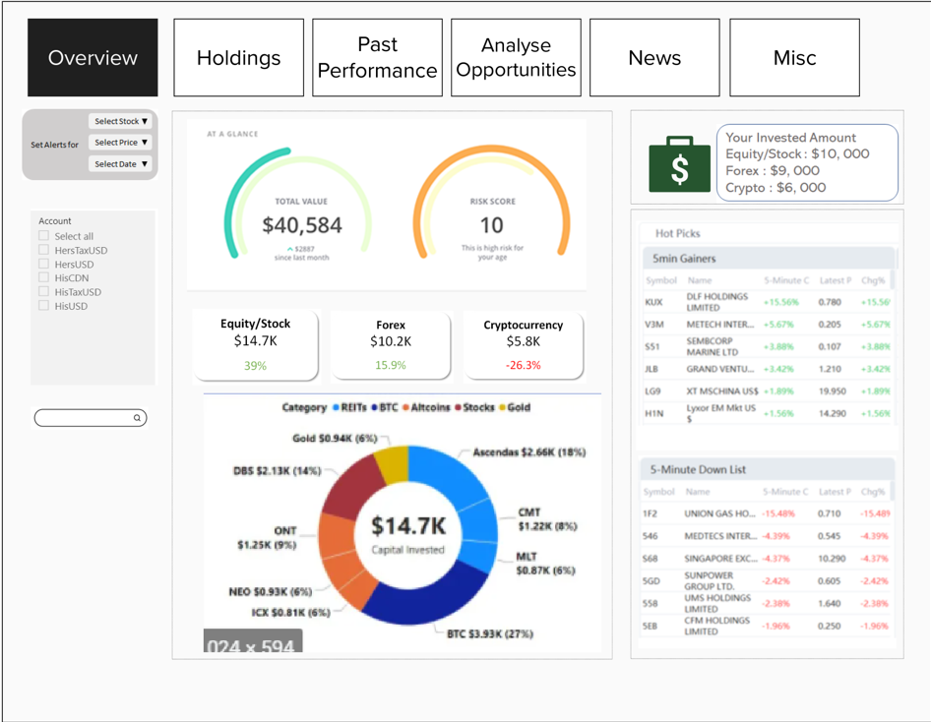

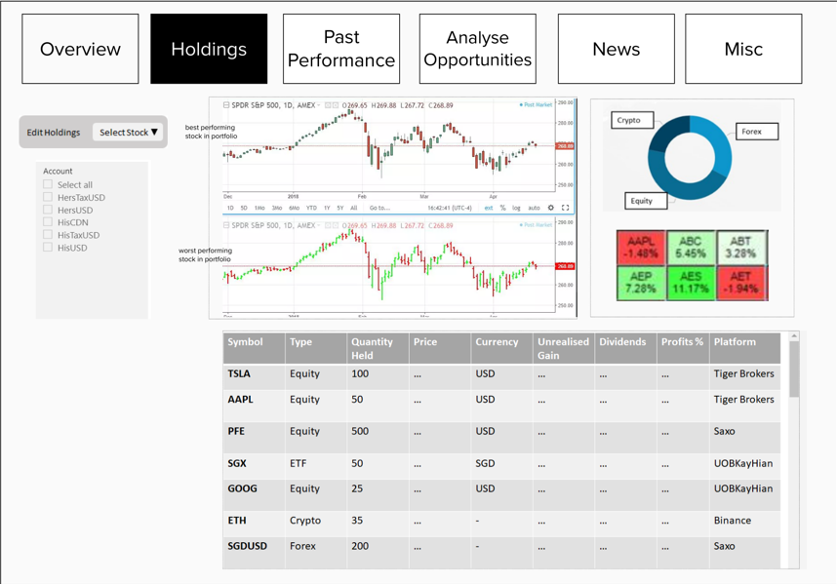

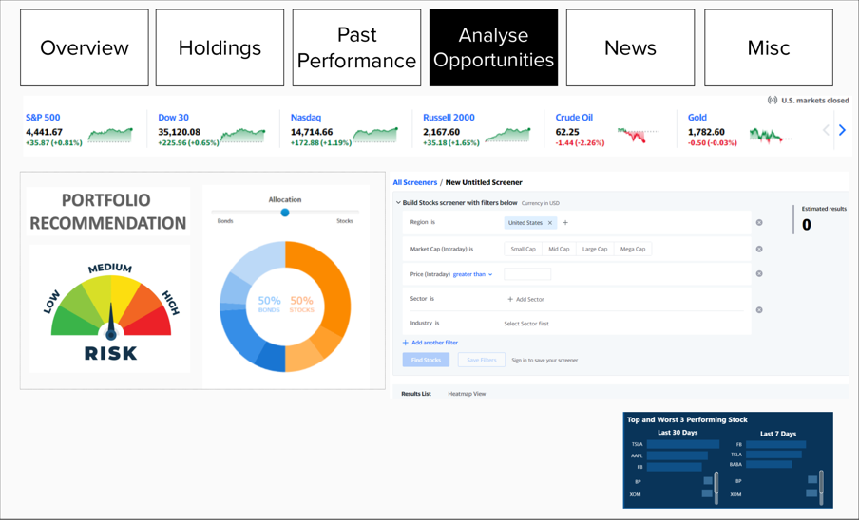

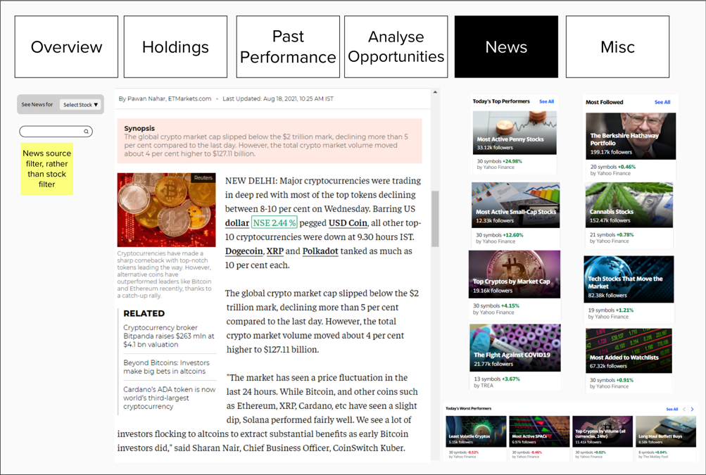

# 3. Data Visualisation in Power BI

The dashboard consists of 3 main data sources - 1 local file and 2 API integrations. The local file is an Excel 365 file, Office 365 is specifically needed as we are using a feature only available in Office 365. The 2 API integrations we use are for the Top Movers list and the News Tab. Data for Daily Top Movers is from [IEX Cloud](https://iexcloud.io/), while the data for the News Tab is from [Polygon](https://polygon.io/).

3.1 Data Sources

This section will elaborate on the data sources we used in this project. We used the stock function available in Excel 365, under Data and selecting the Stocks option.

Step 1: Type the ticker abbreviation in any cell (e.g. AAPL)

Step 2: At the top menu bar, go to **Data**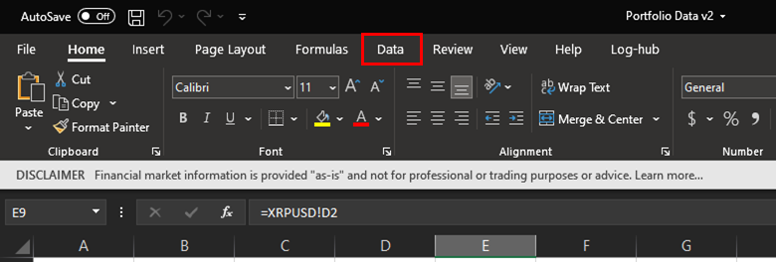

Step 3: Highlight the cell with the ticker abbreviation and click the **Stocks** icon. This automatically converts stock ticker abbreviations into a hyperlink that can also pull in an overview of the company by clicking on the icon beside the company name.

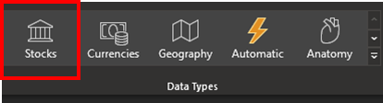

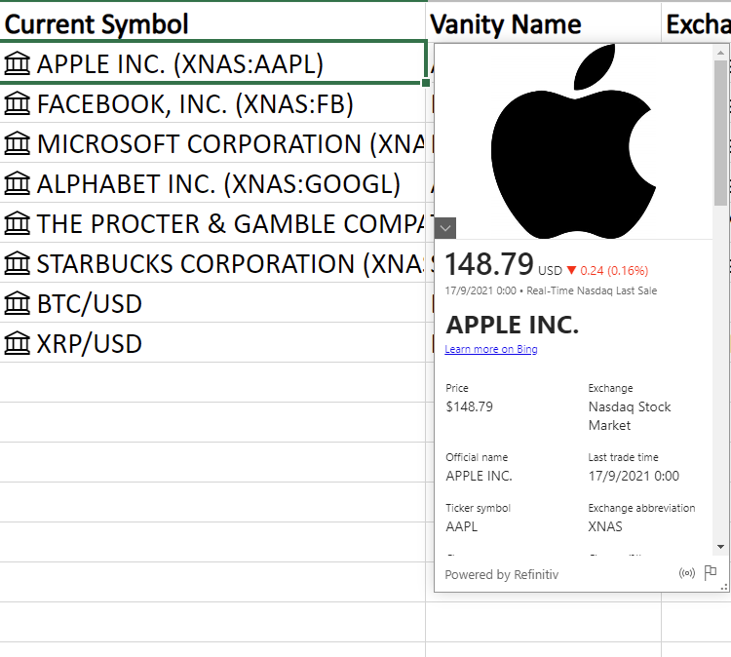

In the event that there are several stocks with similar abbreviations or the same stock listed in different exchanges, a pop-up menu will ask for the user to select the desired stock.

Referencing this special cell allows for calling other information like current prices using the following formula: I2.Price, among other functions that Excel will prompt you about.

Where I2 references the cell with Apple Inc. (XNAS:AAPL). The benefit of doing it this way is that the prices are updated to the current time given the data is available. We trust this data as it is derived from Refinitiv, one of the largest providers of such financial data globally, as documented in Microsoft’s [documentation](https://support.microsoft.com/en-us/office/about-the-stocks-financial-data-sources-98a03e23-37f6-4776-beea-c5a6c8e787e6).

The information we use are the headings for our columns, which is all contained on Row 1.

* Date
* Symbol
* Instrument Type
* Currency
* Price
* Quantity
* Initial Value
* Fees
* Current Symbol
* Vanity Name
* Exchange
* Description
* Open
* High
* Low
* Current Price
* Previous Close
* Change
* Change (%)
* 52 Week High
* 52 Week Low
* Trading Volume
* P/E Ratio
* Beta

By allocating cells to pull out information such as Description, we are able to provide an overview of the equities in our portfolio when we import the data into Power BI.

**Historical Time-series Data**

Historical price data of an equity is derived using the [STOCKHISTORY](https://support.microsoft.com/en-us/office/stockhistory-function-1ac8b5b3-5f62-4d94-8ab8-7504ec7239a8) function within Excel 365 as well. Since this is an Excel formula, we reference the same cells on the Portfolio Data tab in order to align the stocks with any that is present in our portfolio. By doing so, the spreadsheet will update itself should we decide to change any equities in our portfolio.

The following formula is used =STOCKHISTORY(Market!I2,Market!A2,TODAY(),0,1,0,1,2,3,4,5) to generate an array of data with the date ranging from the date referenced in Market!A2 to the current day by using the function TODAY(). The parameters used in the STOCKHISTORY function is as follows =STOCKHISTORY(Stock symbol, start date, end date, interval, headers, property0, property1, property2, property3, property 4, property5). While only the first 2 parameters are strictly mandatory for the array to generate any data, we want data up till the current date. Optional parameters have default values if none are indicated and for our purposes we require more than the default. Microsoft’s own [documentation](https://support.microsoft.com/en-us/office/stockhistory-function-1ac8b5b3-5f62-4d94-8ab8-7504ec7239a8) has more information.

This data has the most recent date at the bottom, allowing any updates to be added easily. In order to import into Power BI easily and neatly, we opted to have each equity in its own tab. The time series data however does not include the ticker symbol of the data, we add this manually as the left most column in the tab. Since new data is always added at the bottom row, and we do not want to unnecessarily add in information for data that is not yet there, we implement an IF condition to check if the adjacent cell to the ticker symbol is blank space or not. If the adjacent cell is blank, the ticker will not appear, but if the cell is not blank, it will display the ticker.

The formula is as follows: =IF(ISBLANK(B2),"",'Portfolio Data'!$B$8)

Each STOCKHISTORY function can only take one stock parameter, we repeat the process of creating the data array for all the stocks we wish to look at, those within our portfolio and those that we want in our pre-defined universe of stocks. For the purposes of this project it should be adequate, although scaling up might be an issue.

## 3.2 Stock News Data

This section will explain how stock related news was brought into the News Tab on the dashboard.

Step 1: Get API Key from Polygon.io

Go to<https://polygon.io/docs/getting-started> and get your free API Key

Step 2: Login at<https://polygon.io/docs/getting-started>.

Go to RESTful API Docs → Ticker News

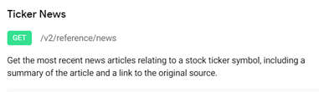

Step 3: In “published_utc” parameter, key in date “01-09-2021”

Copy URL

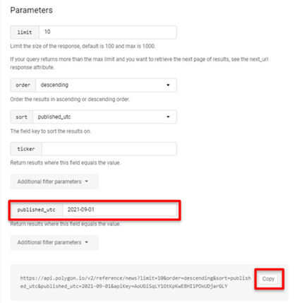

Step 4: In Power BI Home tab, select “Get Data” → “Web”

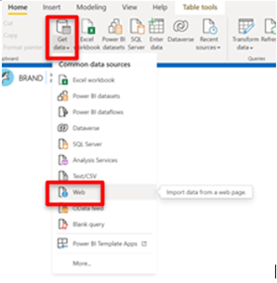

In URL, insert copied link from Step 3

https://api.polygon.io/v2/reference/news?limit=10&order=descending&sort=published_utc&published_utc=2021-09-01&apiKey=*

Click OK

Step 5: In the Power Query Editor that opens up, Click on “Advanced Editor”

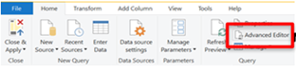

Replace “<https://api.polygon.io/v2/reference/news?limit=10&order=descending&sort=published_utc&published_utc=2021-09-01&apiKey=po_4ZlwdDnD3CPG2FT6mLvFCfs2GCQLz>”

with the below, where [apikey] = Your API key from Step 1

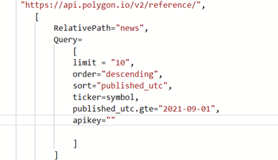

*RelativePath is being used to pass through the parameters that this API needs.*

*“limit” - the cap of number of articles shown  
“order” – by date that article was published  
“sort” – by date that article was published  
“ticker” – the stock symbol (inserted with reference to parameter list on Step 3)  
“published_utc.gte” – start date  
“apikey” – your Polygon.io API key*

Step 6: The full code should look like the below. If so, click “Done”.

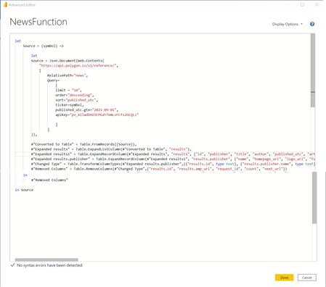

Step 7: Rename as “NewsFunction”

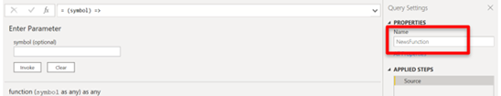

Step 8: Create a table of the stocks to be examined by selecting   
(1) “Enter Data”  
(2) typing in the title “Stock” and name of the stocks   
(3) changing the table name to “News”

Click OK

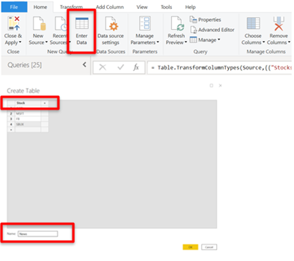

Step 9: Use the function created for each stock by clicking on  
(1) “Add column” 🡪 “Invoke Custom Function”  
(2) Having the Function query as “NewsFunction” and symbol as “Stocks”   
Click OK

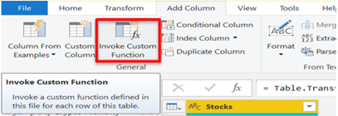

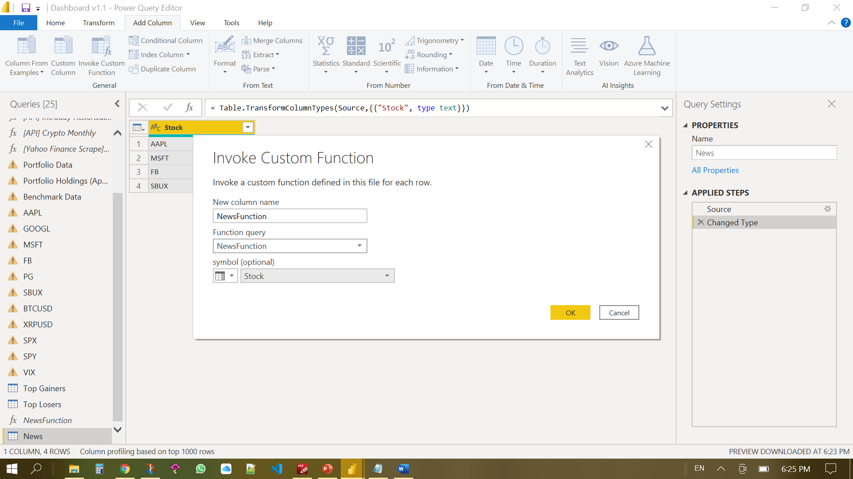

Step 10:   
(1) Expand out the newly created column   
(2) Uncheck columns not needed  
(3) Uncheck “Use original column name as prefix”

Click OK

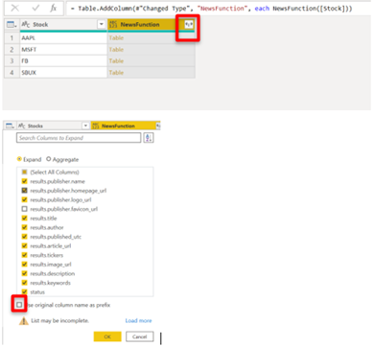

Step 11: Right click and rename columns respectively

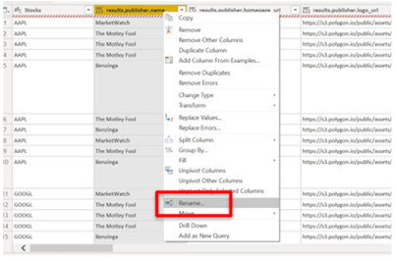

Step 12: Change the type of “Date” column to “Date/Time”

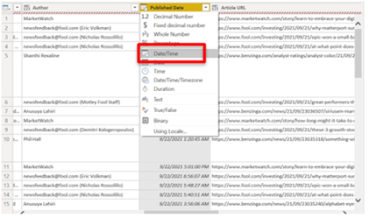

Step 13: Select the “Home” tab 🡪 “Close and Apply”

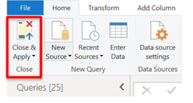

Once done, the data needed for stock news is done.

## 3.3 Daily top movers data

The data source used to generate the list of top movers and gainers visual is derived from IEX Cloud.

Step 1: Go to <https://iexcloud.io/> and get a free account, along with an API key

Step 2: Go to <https://iexcloud.io/docs/api/#list> to see the arguments needed in the url in order to call the correct function. We are using the gainers and losers function which is listed under the examples. Click the hyperlink for the losers and gainers. This will open a new tab, without an API key this will return an error. Take note of the URL, which should look something like this: <https://cloud.iexapis.com/stable/stock/market/list/gainers>

Step 3: Sign in to the IEX website and navigate to API tokens on the left. Take note of the API Token here.

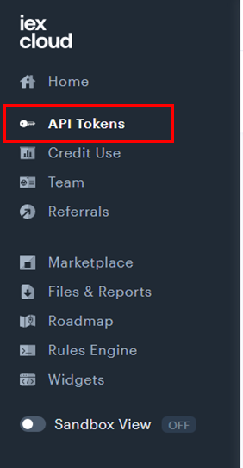

Step 4: Navigate to the Power Query Editor in Power BI

Step 5: Add a new Data Source from Web

Step 6: Use the URL in Step 2 and add the API key from Step 3 by adding to the end of the URL in Step 2 “?token=[insert API Key]”. The end result should look like this:

https://cloud.iexapis.com/stable/stock/market/list/gainers?token=[Insert API Key]

Once done click OK.

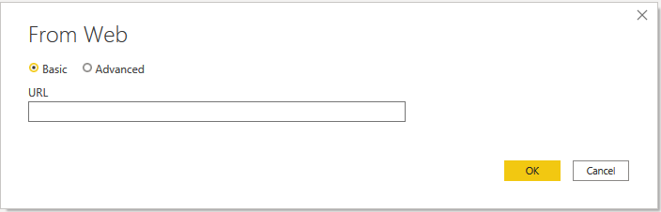

Step 7: The information has been imported into Power BI. Convert the source data to a table; go to **Transform** and click the **To Table** button,

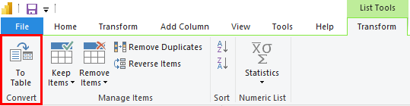

Step 8: Click the expand columns icon in order to extract all the data we need for the Daily Top Movers

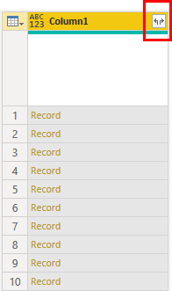

Step 9: Once the columns are expanded, we need to change certain fields in order for Power BI to automatically detect the relationships. The important data we need are the columns **change, changePercent, symbol, company**.

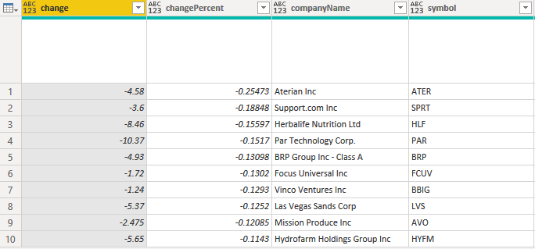

Step 10: Change the type of change from text to decimal numbers, changePercent from text to percentage. Rename changePercent to Change %, this helps easily identify the column when there is a lack of space to display the whole name.

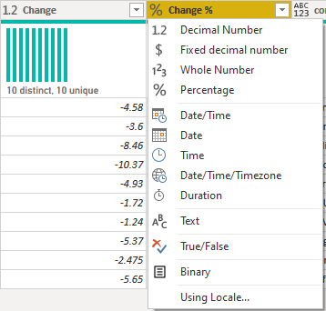

The data needed for the Daily Top Losers/Winners is ready.

## 3.4 Dashboard Modelling

Getting our data into Power BI

Our dashboard relies on data populated within a Microsoft excel file. In order to work with this data in Power BI Desktop, we have to import it into Power BI.

1. Launch Power BI Desktop and select **Get Data** > **Excel Workbook**
2. Select the Microsoft excel file: **Portfolio Data.xlsx**
3. On the Navigator window, select all the required excel data worksheets then click **Transform Data**.

Preparing the data in Power Query Editor

Review each data query in the Queries (left) pane of Power Query Editor to ensure that all data columns are assigned the correct data type. To change a columns data type:

1. Right click on the column header and select **Change Type**.

Our data will consist primarily of the following data types:

**Text**: Stock symbols, Currency, Asset descriptions

**Date**: Date ranges

**Fixed Decimal Number**: Prices (Open, High, Low, Close)

**Decimal Number**: Measures & Ratios (P/E Ratio, Beta)

**Whole Number**: Trading Volume

**Percentage**: Measures of difference

Remove empty columns and rows, if any, from each data table.

1. To remove a data column, right click on the column header > **Remove**
2. Empty rows can be removed by selecting **Remove Rows** > **Remove Blank Rows** on the Power Query Editor ribbon.
3. Once complete, proceed to click **Close & Apply** to return to Power BI Desktop

# 

# 

# 

Create new data tables by appending queries

Our source data is compartmentalized in that each stock asset or benchmark has its own separate data table. However, to create charts and visualizations that include multiple stocks or benchmarks, we need to combine them into a single data table by appending them together.

1. On Power BI desktop, select **Transform Data** on the ribbon to bring up Power Query Editor
2. In the Power Query Editor, on the left Queries pane, highlight the first data table to append
3. Select the **Append Queries** drop down menu > **Append Queries as New**
4. Select the option **Three or more tables**
5. Move the desired tables from the **Available tables** section to the **Tables to append** section
6. Select **OK** when done

We will need to append the following tables:

AAPL, GOOGL, FB, MSFT, PG, SBUX, BTCUSD, XRPUSD == **Portfolio Holding (Append)**

AAPL, GOOGL, FB, MSFT, PG, SBUX, AMD, NVDA, INTC, PFE == **Portfolio & Market Data (Append)**

NDX, SPY, XMI == **Benchmarks (Append)**

Portfolio Data, Market Data == **Portfolio & Market Summary (Append)**

# 

Creating calculated columns and measures

We need to calculate certain values such as the value of our portfolio, its daily change or the investment returns from prices available in our data tables. This allows us to present valuable information to our users quickly.

To create the necessary calculated columns:

1. Right click on the **Portfolio Data** table in the Fields pane at the right of Power BI Desktop
2. Select **New column**
3. In the DAX editor, enter the following to create a calculated column  
   Current Value = 'Portfolio Data'[Current Price] * 'Portfolio Data'[Quantity] - 'Portfolio Data'[Fees]
4. Create another calculated column with the following DAX formula:  
   Previous Value = 'Portfolio Data'[Previous Close] * 'Portfolio Data'[Quantity] - 'Portfolio Data'[Fees]

To create the necessary measures:

1. Right click on the **Portfolio Data** table in the Fields pane at the right of Power BI Desktop
2. Select **New measure**
3. In the DAX editor, enter the following to create a new measure  
   Daily Change % = (SUM('Portfolio Data'[Current Value]) - SUM('Portfolio Data'[Previous Value])) / SUM('Portfolio Data'[Previous Value])
4. Create another measure with the following DAX formula:  
   Total Return = SUM('Portfolio Data'[Current Value]) - SUM('Portfolio Data'[Initial Value])
5. Create the final measure with the following DAX formula:  
   Total Return % = (SUM('Portfolio Data'[Current Value]) - SUM('Portfolio Data'[Initial Value])) / SUM('Portfolio Data'[Initial Value])

# 

Modeling our data in Power BI

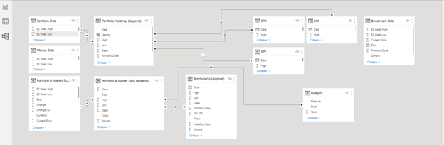

Our data consists of multiple data tables, some of which are designed to work together to produce relevant visuals. Creating model relationships between data tables will enable us to do so, though not every table needs to have relationships with one another.

1. To access the Modeling view, select the **Model** icon found on the left side of Power BI Desktop
2. On the All tables model tab we can review all our data queries. To create a relationship:
3. Right click on a data query and select **Manage relationships**.
4. On the manage relationships window, select **New…** on the bottom left.
5. Select the different data tables you wish to create a relationship between in the drop-down menus.
6. Select the data columns that will relate both data tables by clicking and highlighting them as described below.

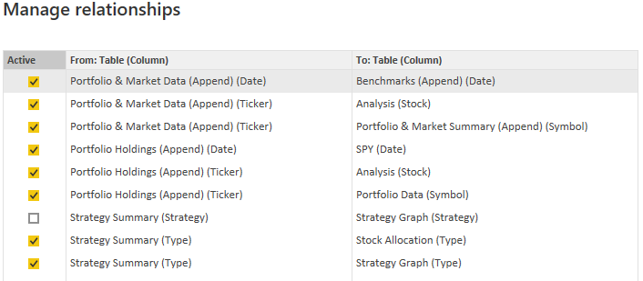

The Power BI relationship designer will automatically detect and set the cardinality type. We will use the default values set by Power BI Desktop for our model. Select **OK** when done.

# 

Getting custom visuals into Power BI

Before we begin working on our visualization, we will need to install a few additional Power BI visuals, not available in the standard Visualizations pane.

1. Select the Report icon on the left Power BI Desktop to bring up the Report view
2. On the Visualizations pane, select the **…** meatballs menu.
3. Click **Get more visuals**
4. Search for following visuals individually and install them by clicking **Get It Now**(Text Filter, Sunburst, Radar Chart, Card Browser)

### 3.4.1 Creating the Overview visualization

The Overview visualization provides a summary of our portfolio and consists of four(4) main visuals.

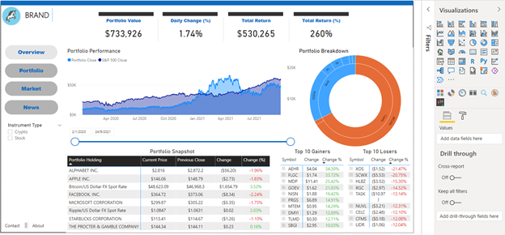

The Portfolio Performance shows the value of our portfolio over time, compared against the S&P 500 index. To create this visual:

1. Select the **Report** icon found on the left side of Power BI Desktop
2. Navigate to the visualizations pane on the right and select the **Area Chart** visual
3. Drag the following data fields into the visualization inputs

| **Input field** | **Table** | **Data field** |
| --- | --- | --- |
| Axis | Portfolio Holding (Append) | Date |
| Values | Portfolio Holding (Append) | Portfolio Close |
| Secondary Values | SPX S&P 500 | Close |

The Portfolio Breakdown is a graphical representation of our portfolio and its underlying assets. To create this visual:

1. Navigate to the visualizations pane on the right and select the **Sunburst** visual that was installed.
2. Drag the following data fields into the visualization inputs

| **Input field** | **Table** | **Data field** |
| --- | --- | --- |
| Groups | Portfolio Data | Instrument Type, Symbol |
| Values | Portfolio Data | Current Value |

The Portfolio Snapshot shows daily performance of each asset in our portfolio. To create this visual:

1. Navigate to the visualizations pane on the right and select the **Matrix** visual.

| **Input field** | **Table** | **Data field** |
| --- | --- | --- |
| Rows | Portfolio Data | Portfolio Holding |
| Values | Portfolio Data | Current Price, Previous Close, Change, Change (%) |

1. Drag the following data fields indicated below into the visualization field inputs
2. Click on the **Format** button within the Visualization pane
3. Under **Conditional formatting**, select Change (%) in the contextual menu
4. Enable Font color and click Advanced controls
5. Ensure that the following conditions are set

The Top 10 Gainers. To create this visual:

1. Navigate to the visualizations pane on the right and select the **Matrix** visual.
2. Drag the following data fields into the visualization inputs

| **Input field** | **Table** | **Data field** |
| --- | --- | --- |
| Rows | Top Gainers | Symbol, companyName |
| Values | Top Gainers | Change, Change (%) |

The Top 10 Losers. To create this visual:

1. Navigate to the visualizations pane on the right and select the **Matrix** visual.
2. Drag the following data fields into the visualization inputs

| **Input field** | **Table** | **Data field** |
| --- | --- | --- |
| Rows | Top Losers | Symbol, companyName |
| Values | Top Losers | Change, Change (%) |

The end result should be as follows:

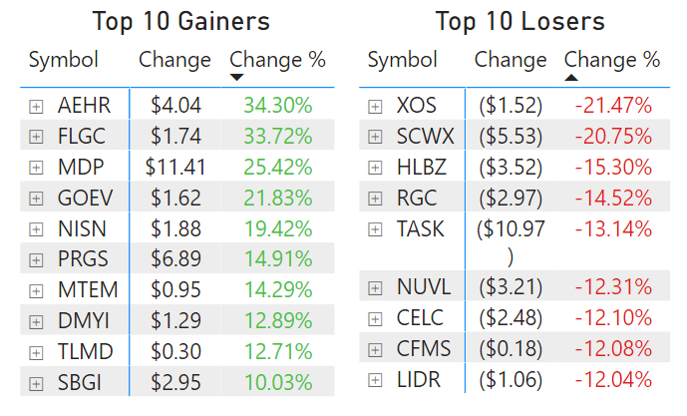

### 3.4.2 Creating the Portfolio visualization

In this portfolio dashboard, you can see a clear overview of your assets, stock performances, Radar and Candlestick charts, which are used by traders to determine possible price movements based on past trends.

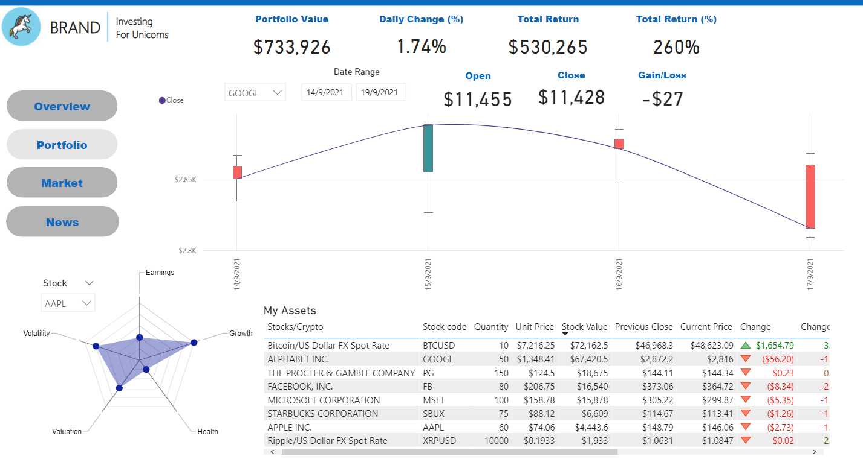

Portfolio dashboard

This visual was created by dividing the information into four sections.

Firstly, the overall performance portfolio values with daily changes as well as total returns shown at a glance. You can monitor any changes in the values of this portfolio at any time.

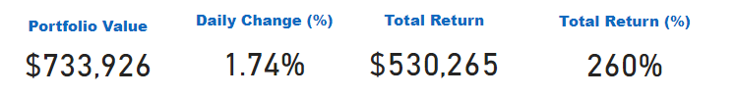

Portfolio performance in one glance

To create this visual:

1. Navigate to the visualizations pane on the right and select the **Card** visual.
2. Drag the following data fields (Portfolio Data) into the visualization inputs (Fields) shown (Fig 1.1).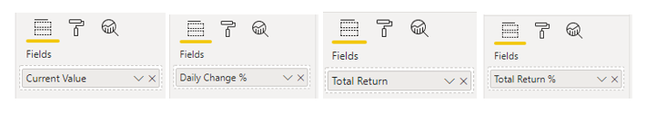

Secondly, Candlestick charts provide investors with a way to monitor possible price movement based on previous patterns. Candlesticks are helpful when trading because they show four price points (open, close, high, and low) throughout the time period specified. The same price information that appears in candlestick charts is also used by numerous algorithmic trading systems. Trading is often determined by emotion, which can also be read by candlestick charts.

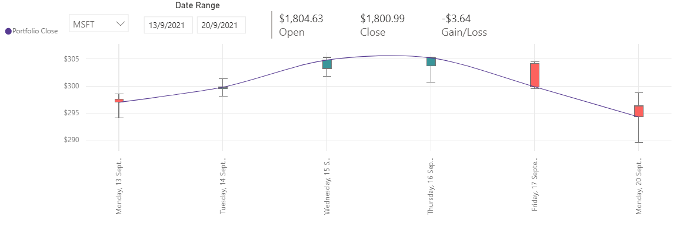

Candlestick charts showing price movement based on past patterns

To create candlestick visual: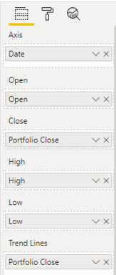

1. Navigate to the visualizations pane on the right and select the **Candlestick** visual that was installed.
2. Drag the following data fields (Portfolio Holdings – Append) into the visualization inputs shown ( Fig 2.1)
3. Navigate to the visualizations pane on the right and select the **Card** visual and drag the following data fields (Portfolio Holdings – Append) into the visualization inputs shown ( Fig 2.2)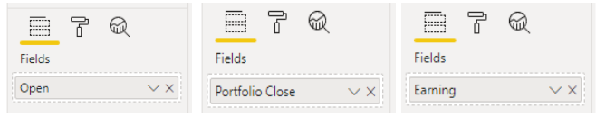



4. Navigate to the visualizations pane on the right and select the two individual **Slicer** visual.

5. Drag the following data fields (Portfolio Holdings – Append) namely Stock code (Ticker) and Date range (Date) into the visualization inputs Fig 2.3 and Fig 2.4 respectively .

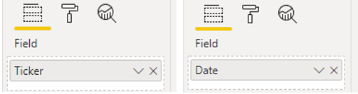

Thirdly, in this table investors can view their portfolio value, performance, allocations, and basic information about the stocks and cryptocurrency they own up to date.

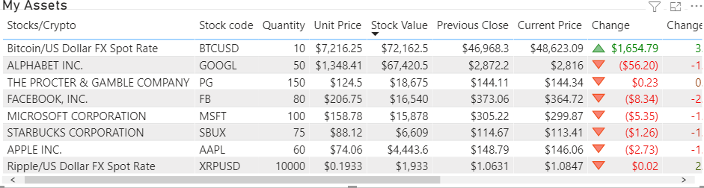Investor Assets Overview

To create this visual:

1. Navigate to the visualizations pane on the right and select the **Table** visual.
2. Drag the following data fields (Portfolio Data) into the visualization inputs under Values shown ( Fig 3.1).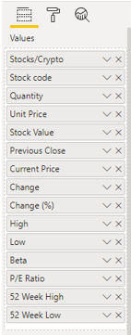



Lastly, Radar chart tool allows you to see what is happening over multiple variables with a quick glance using a chart. This feature displays earnings, volatility, growth, valuation and health of the selected stock.

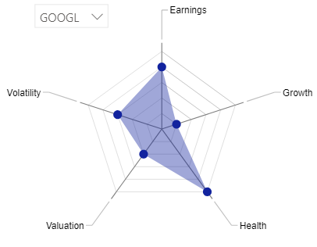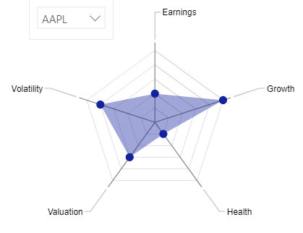

Radar chart stock code: GOOGL Radar chart stock code: AAPL

To create this visual:

1. Navigate to the visualizations pane on the right and select the **Radar Chart 2.0.2** visual that was installed.
2. Drag the following category and axis (Analysis) into the visualization inputs shown (Fig 4.1) .

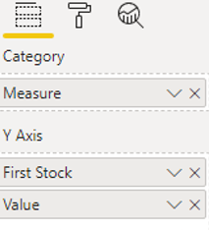

1. Navigate to the visualizations pane on the right and select the **Slicer** visual.
2. Drag the following category (Analysis) into the visualization inputs Field shown (Fig 4.2) .  
    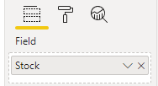

### 

### 

### 3.4.3 Creating the Market visualization

The Market visualization allows our users to look up various stocks and get detailed information about the company, the stock’s price movements, along with analyst ratings. It is made up of 2 primary visuals.

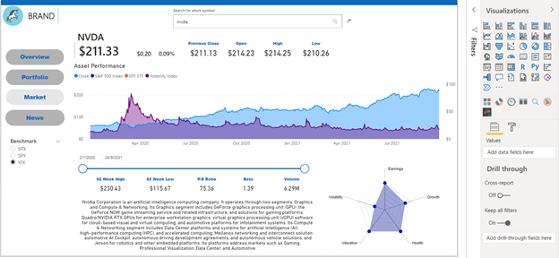

The Asset Performance chart shows a stock’s performance over time against a backdrop of different benchmarks. To create this visual:

1. Select the **Report** icon found on the left side of Power BI Desktop
2. Navigate to the visualizations pane on the right and select the **Area Chart** visual
3. Drag the following data fields into the visualization inputs Input field Table Data field Axis Portfolio & Market Data (Append) Date Values Portfolio & Market Data (Append) Close Secondary Values Benchmarks (Append) Close
4. Add a Slicer visual with the Ticker data field of the Benchmarks (Append) table.

The radial chart provides stock analyst ratings against predetermined criteria. To create this visual:

1. Navigate to the visualizations pane on the right and select the **Radar Chart 2.0.2** visual that was installed.
2. Drag the following data fields into the visualization inputs

| **Input field** | **Table** | **Data field** |
| --- | --- | --- |
| Category | Analysis | Measure |
| Y Axis | Analysis | Stock, Value |

### 3.4.4 Creating the News visualization

The News visualization allows our users to lookup news for selected stocks.

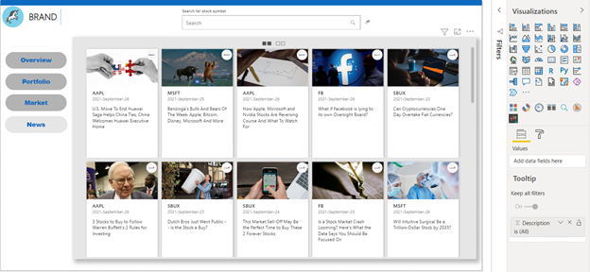

To create this visual :

Step 1: In Report view, select “Get more visuals” from the Visuals pane

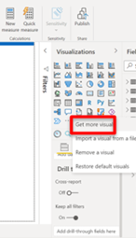

Step 2: Search for “card browser”, click “Get it now”

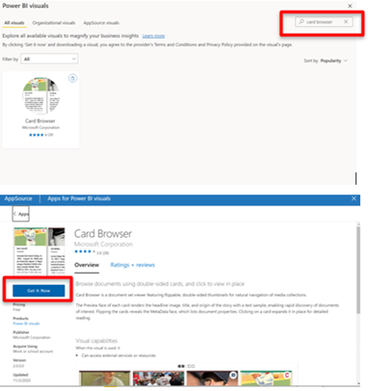

Step 3: Create Visualisation - Click on Card Browser visualisation

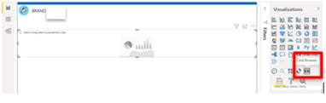

Step 4: Drag the following fields to the respective tabs in the Visualisation tab

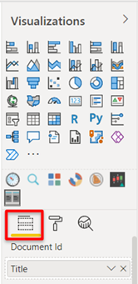

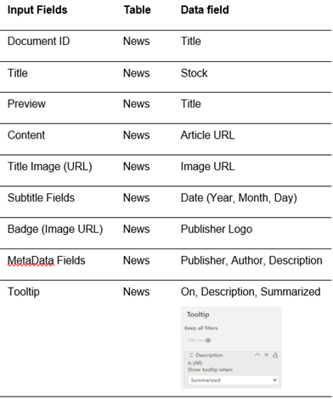

Step 5: Format Visualisation, Enter the following

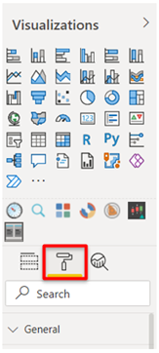

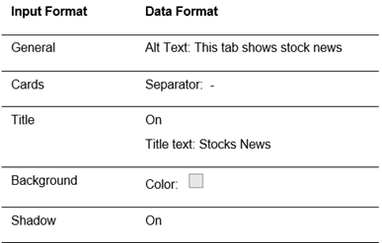

**Phase 2 Documentation**

Algorithmic Trading

# Table of Contents

## 1. Strategies

## 1.1 Asset Momentum

Introduction

Method

Strategy Thought Process

References

1.2 Capital Asset Pricing Model (CAPM) Alpha Ranking Strategies on Dow 30 Companies

Introduction

CAPM Theory

Strategy Thought Process

References

1.3 Cryptocurrency - Strategy using RSI for Entry and Exit Point

Introduction

Strategy Thought Process

Observation and Results

Recommendations/Conclusions

Algorithm & Parameters

References

2. Portfolio Management using Modern Portfolio Theory (MPT)

Extraction of Backtest Data

2.1 QuantConnect

2.2 MS Excel

2.3 Google Sheet

2.4 Google Colab

## 3. Results & Findings

# 1. Strategies

## 1.1 Asset Momentum Strategy

#### Introduction

This is a trend following algorithm that determines its entry points using the momentum effect.

The momentum anomaly states that there is a tendency for assets that have shown strong past performance to continue that performance into the near future. This strategy will capitalize on the notion that rising asset prices will continue to rise.

The calculation performed uses the rate of change in price movements for a particular asset over a trading period of 6 months and is benchmarked against the S&P 500 Index.

#### Method

#### The portfolio of this algorithm contains 6 stocks which make up our holdings and the SPX benchmark. We chose a period of 6 months for the following calculations.

#### Utilizing the LEAN engine's momentum indicator self.MOM(symbol, period, resolution) we ranked the 6 stocks and the SPX benchmark after obtaining the most recent momentum value.

#### Momentum is calculated as the absolute difference in stock/index prices.

*Momentum = Close(today) − Close(6*21 days ago)*

#### 

#### Each week, the strategy is scheduled to rebalance itself via the self.Schedule.On event.

#### If all 6 stocks have a momentum value greater than that of the SPX benchmark, we will add them into our portfolio and weight them based on optimized allocations for either a low volatility or high sharpe ratio portfolio.

#### The stocks will be held for one week and then the strategy will re-evaluate the portfolio and rebalance with new momentum values.

#### Strategy Thought Process

#### Our thought process is loosely based on the simple trading rule that only the best performing assets are held.

#### In the case of this strategy, we want to ensure that:

#### We’re holding our assets at optimal allocations only when their momentums exceed that of the market, as denoted by the SPX.

1. We liquidate our positions if the asset’s momentum value falls below that of the market.

#### References

Jegadeesh, N; Titman S (1999). "Profitability of Momentum Strategies: An Evaluation of Alternative Explanations"

<https://www.nber.org/papers/w7159>

Quantpedia strategy overview

<https://quantpedia.com/strategies/asset-class-momentum-rotational-system/>

### 

### 

### 

### 

## 1.2 Capital Asset Pricing Model (CAPM) Alpha Ranking Strategy on Dow 30 Companies

#### Introduction

The Capital Asset Pricing Model (CAPM) was developed by William F Sharpe and Harry Markowitz. The model is used to determine a rate of return of an asset, to make decisions about adding assets to a well-diversified portfolio.

#### CAPM Theory

The capital asset pricing model (CAPM) describes the relationship between systematic risk and expected return for assets, typically stocks. The formula for calculating the expected return of an asset given its risk is as follows:

ra=rf+βa∗(rm−rf)+ϵ

where:

rf=RiskFreeRater

β=Betaofthesecurity

rm=Expectedmarketreturn

ϵ=Trackingerror

This formula can be better understood if we refactor the formula as seen below:

(ra−rf)=βa∗(rm−rf)+ϵ

The left side of the equation gives us the difference between the asset return and risk-free rate, the “excess return”. If we regress the market excess return against the asset excess return the slope represents the “beta” of the asset. Therefore, beta can also be calculated by the equation:

β=Cov(ra,rb)var(rb)

So, beta can be described as:

β=ρa,b∗σaσb

The formula above indicated that beta can be explained as “correlated relative volatility”. To make this simpler, beta can be calculated by doing a simple linear regression which can be viewed as a factor to explain the return, and the tracking error can represent alpha. To make this theory more convenient for our algorithm, we change the above formula into the following form:

ra=β∗rm+rf∗(1−β)+ϵ

r*(1-β) on the right hand side of the equation is a very small item, making it negligible in the context of Dow 30 companies. If we regress the stocks return with the return of the benchmark, the slope and intercept will be beta and alpha.

#### Strategy Thought Process

Our investment logic is simple and straightforward. We assume that stocks which beat the market last month will continue the market. We rank stocks according to their alpha, and each month we “long” the selected stocks. For this strategy to work, we need to do the following at the start of each month:

* Get the historical price of Dow 30 stocks in the past 21 trading days and calculate their daily rates of return.
* Conduct simple linear regression on the return of each stock against a benchmark (S&P 500 index, SPY)
* Rank the stocks by their intercepts.

#### References

Sharpe, William (1990)

<https://www.nobelprize.org/prizes/economic-sciences/1990/sharpe/lecture>

Fama, Eugene F., French Kenneth R (2003). The Capital Asset Pricing Model: Theory and Evidence. Available at SSRN: <https://papers.ssrn.com/sol3/papers.cfm?abstract_id=440920>

More information from QuantConnects’s strategy library: <https://www.quantconnect.com/tutorials/strategy-library/capm-alpha-ranking-strategy-on-dow-30-companies>

## 1.3 Cryptocurrency - Strategy using RSI for Entry and Exit Point

#### Introduction

The relative strength index (RSI) is a momentum indicator used in technical analysis that measures the magnitude of recent price changes to evaluate overbought or oversold conditions in the price of a stock or other asset.

The RSI is traditionally interpreted in that values of 70 or above indicate that a security is becoming overbought or overvalued and a trend reversal or corrective pullback in price might be likely. An RSI reading of 30 or below indicates an oversold or undervalued condition.

An asset that is oversold is believed to be trading under its true value, and has a high probability of rebounding to the upside in the otherwise normal market conditions. Conversely, an overbought asset is one that trades at a premium and has a high probability of correcting to the downside.

Since the indicator displays momentum, it can stay overbought or oversold for a long time when an asset has significant momentum in either direction. Therefore, the RSI is most useful in an oscillating market such as cryptocurrencies, where the asset price is alternating between bullish and bearish movements.

When spot trading in a reasonable time frame, it’s possible to profit from buying in oversold regions and selling in overbought regions. For example, buying 1 BTC at $6500 and selling it $7000 yields a profit of $500.

#### 

#### Strategy Thought Process

This simple strategy looks at identifying cryptocurrencies with

(i) an upward momentum (sufficiently high 30 day average daily dollar volume)

(ii) buys until momentum fades (buy when RSI hits 70, and sell when RSI reaches 60)

The cryptocurrency pairs selected are from Bitfinex. Bitfinex is a digital asset exchange offering markets for 52 countries across a wide variety of symbol pairs.

#### 

#### Algorithm & Parameters

self.Settings.FreePortfolioValuePercentage = 0.05

Ensures that 5% of portfolio is always in cash, useful to have a cash buffer for portfolio

self.positionSizeUSD = 5000 # amount allocated to single position

self.rsiEntryThreshold = 70 # entry position if rsi rises above this threshold

self.rsiExitThreshold = 60 # exit position if rsi drops below this threshold

self.minimumVolume = 1000000 # filters out symbols with 30 day avg daily dollar volume less than this

#### 

#### References

**What Is RSI and How Do You Apply It to Crypto Trading?**

https://learn.bybit.com/trading/what-is-rsi-and-how-do-you-apply-it-to-crypto-trading/#:~:text=RSI%20is%20commonly%20used%20to,value%20is%2030%25%20or%20below.

**How to use RSI indicators to find entries and exits in crypto trading**

https://blog.liquid.com/how-to-use-the-rsi-indicator-to-find-entries-and-exits-when-margin-trading-crypto

# 2. Portfolio Management using Modern Portfolio Theory (MPT)

### Extraction of Backtest Data

#### 2.1 QuantConnect

Firstly, run algorithm backtest on QuantConnect, using the following timeline period:

self.SetStartDate(2016, 1, 1)

self.SetEndDate(2021, 10, 1)

In the ‘Overview’ tab in QC backtest results, right click "Download Results" and save link as JSON

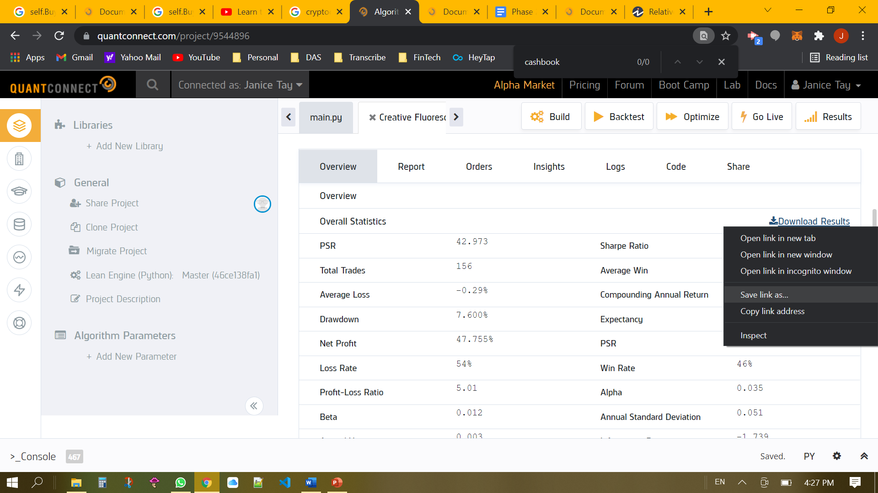

#### 

#### 2.2 MS Excel

In MS Excel retrieve the downloaded file

Step 1: Click “Get data” select “as JSON”

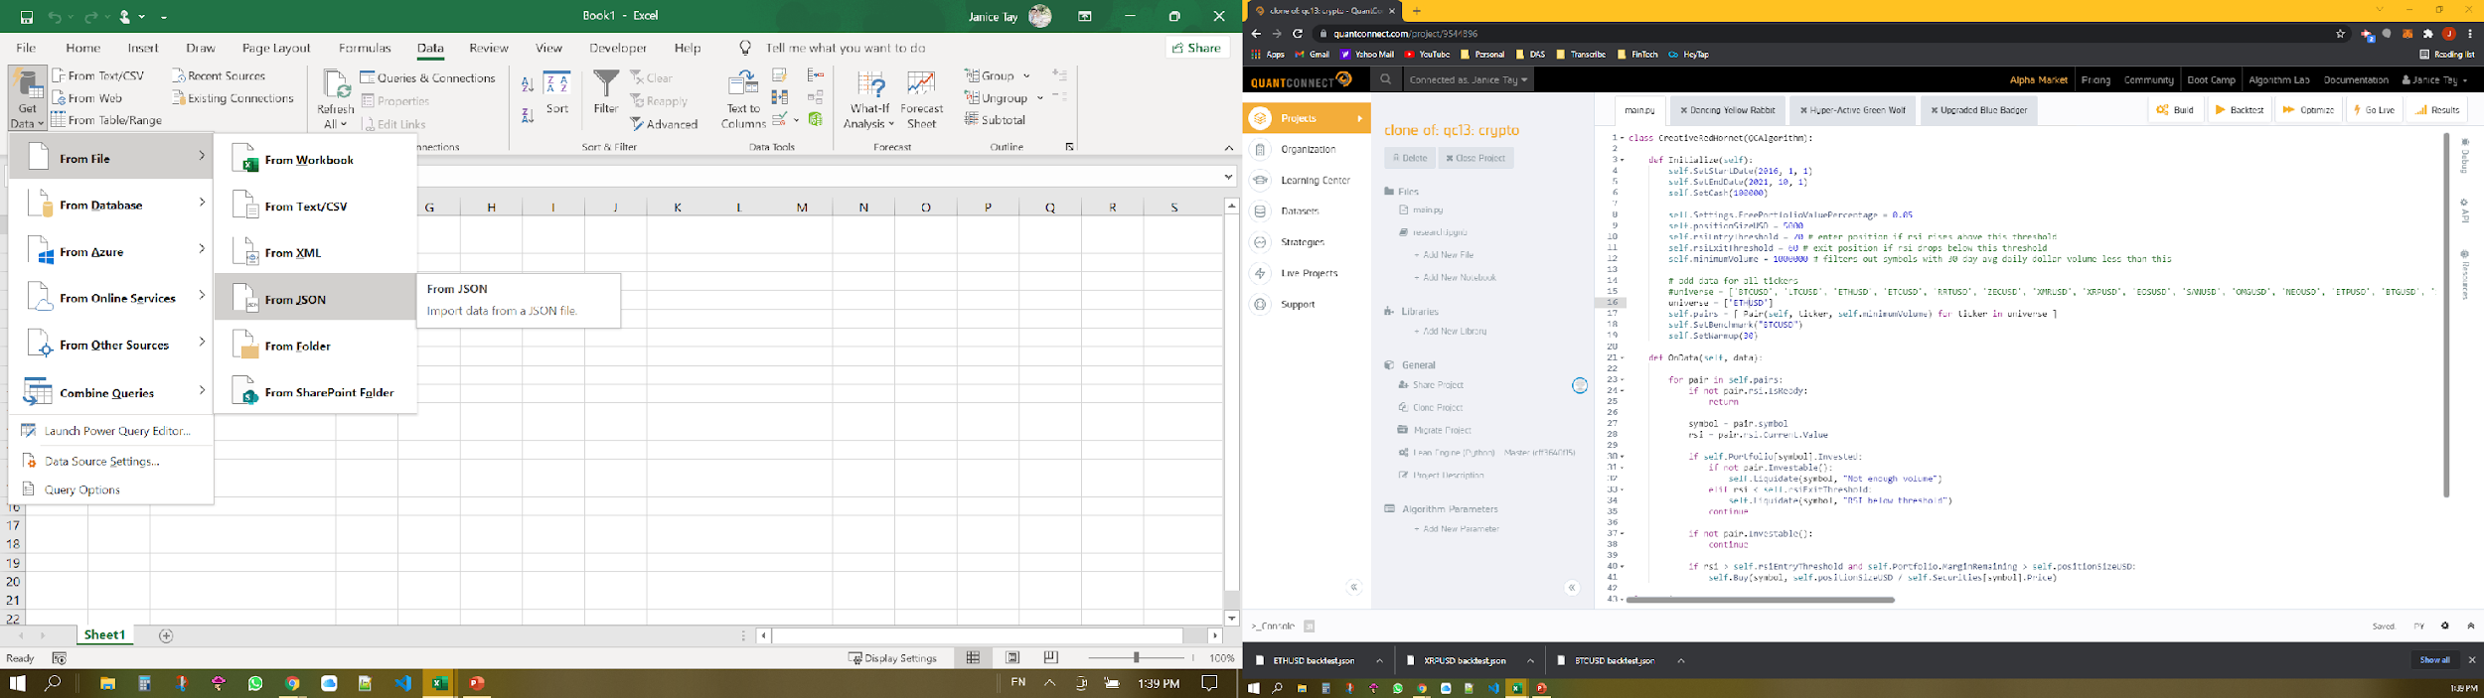

Thereafter, we will need to expand the data accordingly

Step 2: Click "Record" in Chart

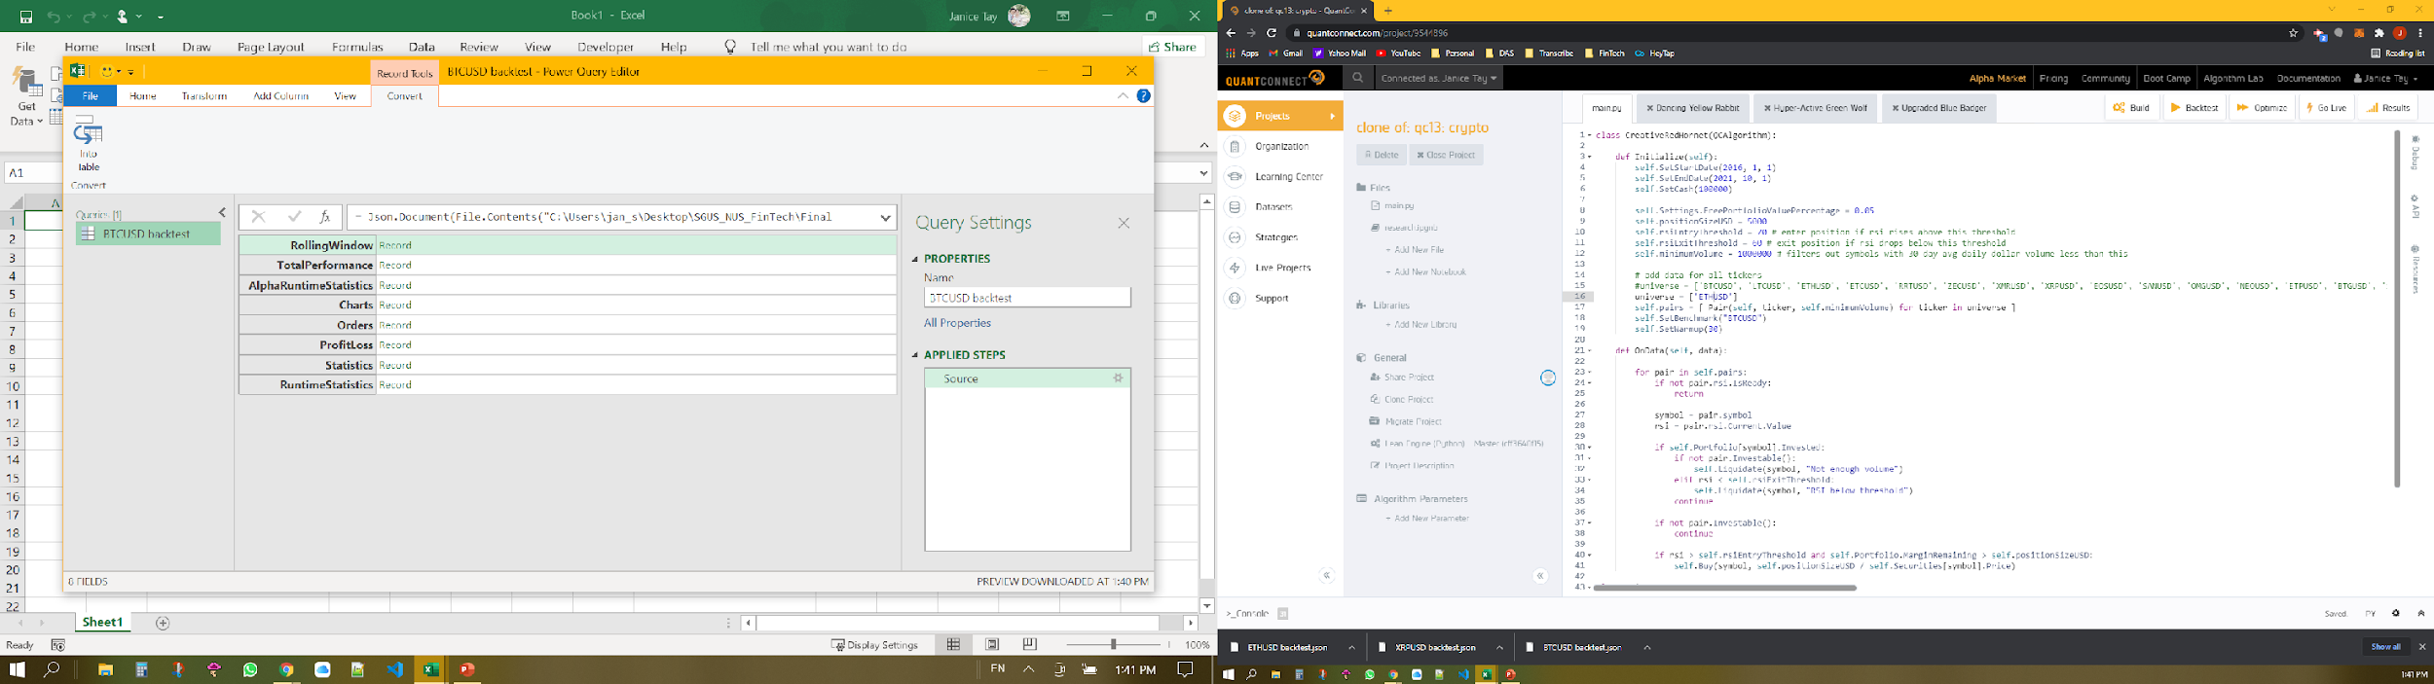  


Step 3: Click "Record" in Strategy Equity

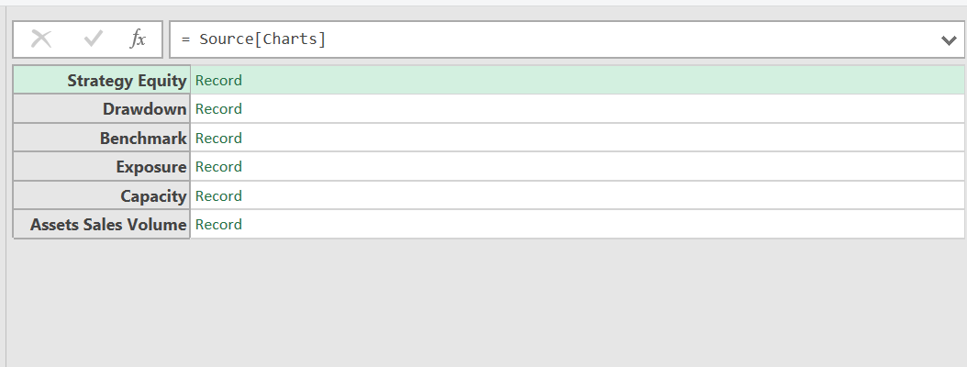  


Step 4: Click "Record" in Series

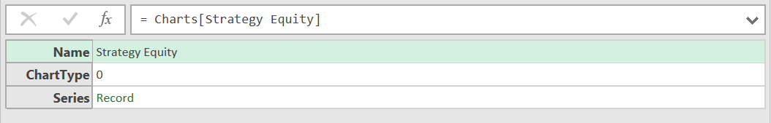  


Step 5: Click "Record" in Equity

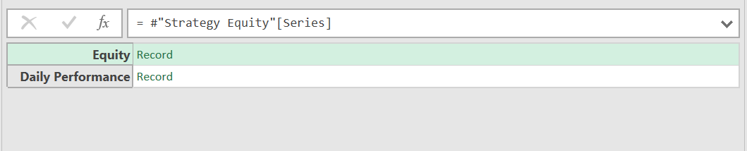  


Step 6: Click "List" in Values

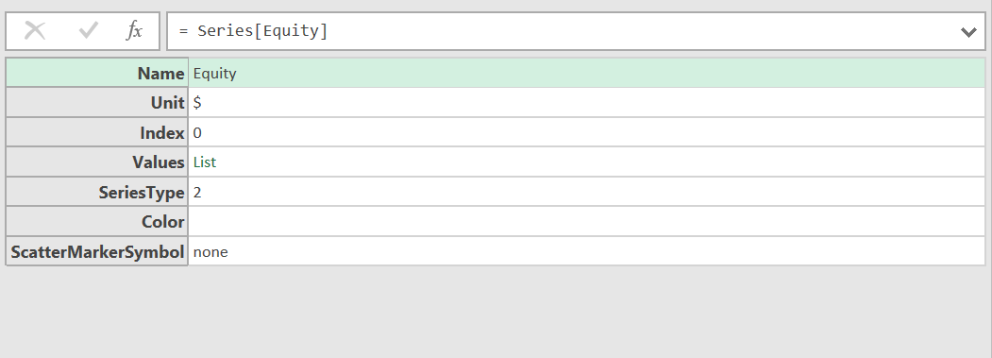  


Step 7: Click "To Table Convert"

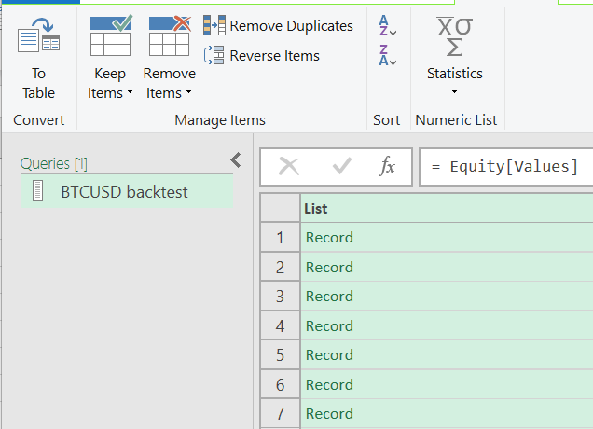  


Ensure that Delimiter is ‘None’   
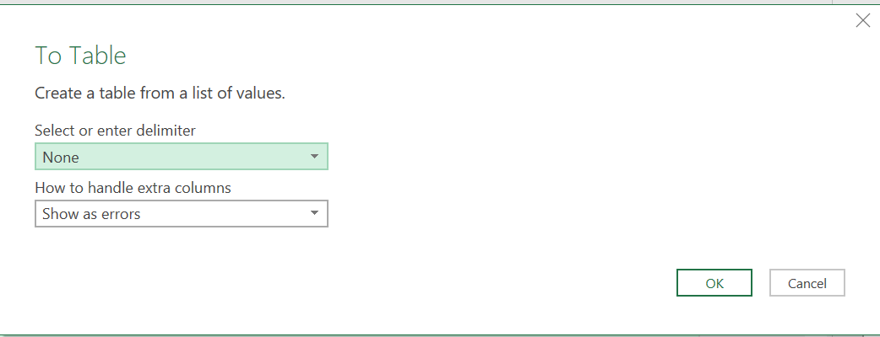

Step 8: Click “Expand”

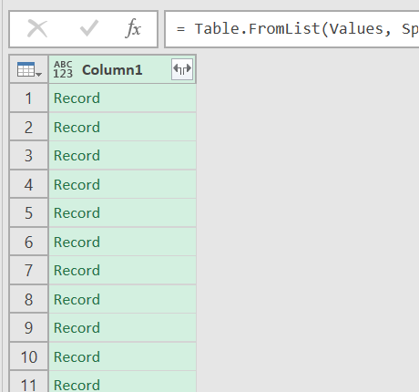  


Ensure x and y are selected

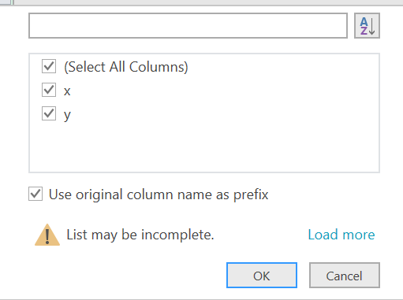

Step 9: Finally, “Close and Load” the table.

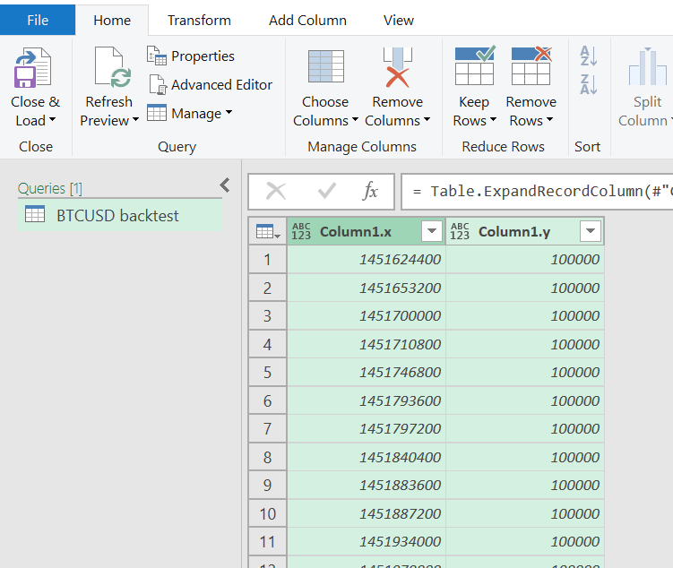

#### 2.3 Google Sheets

Step 1: Copy data to Google Sheets:

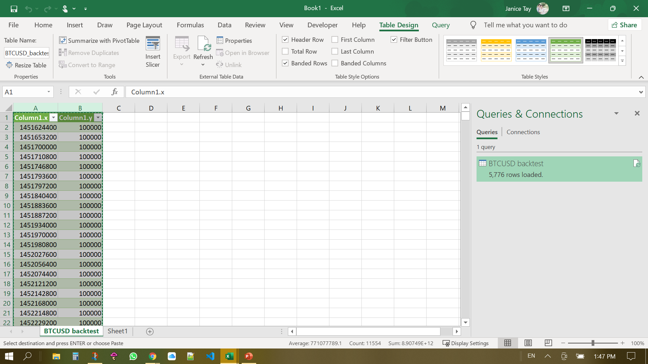

Step 2: Change UNIX timestamp to Date 

=TO_DATE(INT((B2/(60*60*24))+"1/1/1970"))

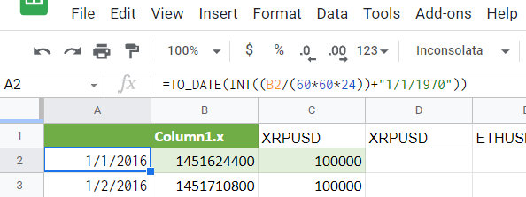

Step 3: Remove duplicate rows

On the Data tab, select “Remove duplicates”

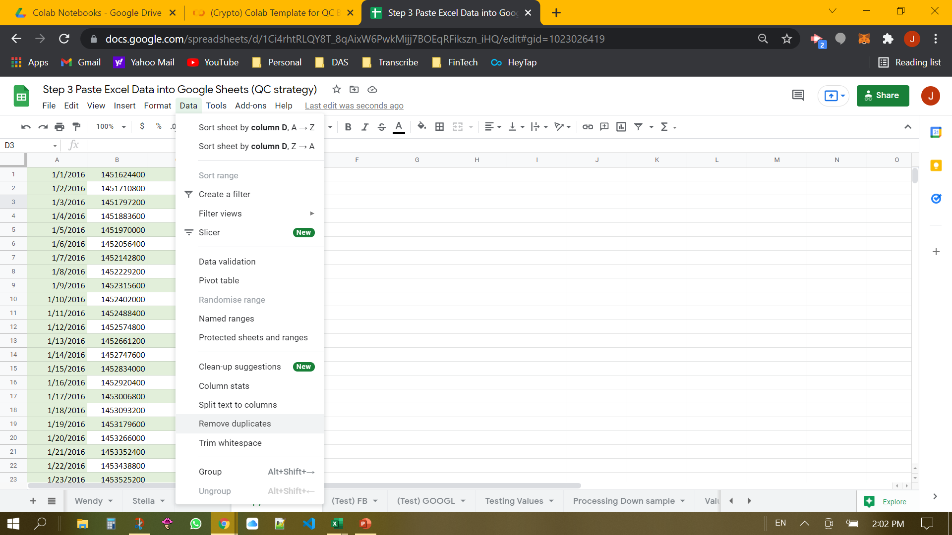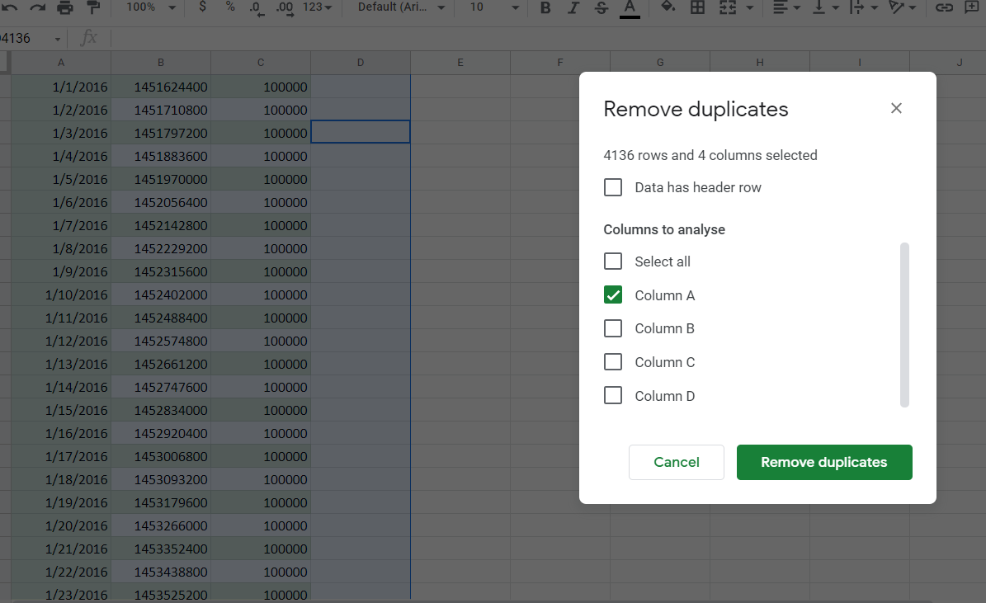

Step 4: Copy and paste date and/or price data as ‘values only’ into a separate tab

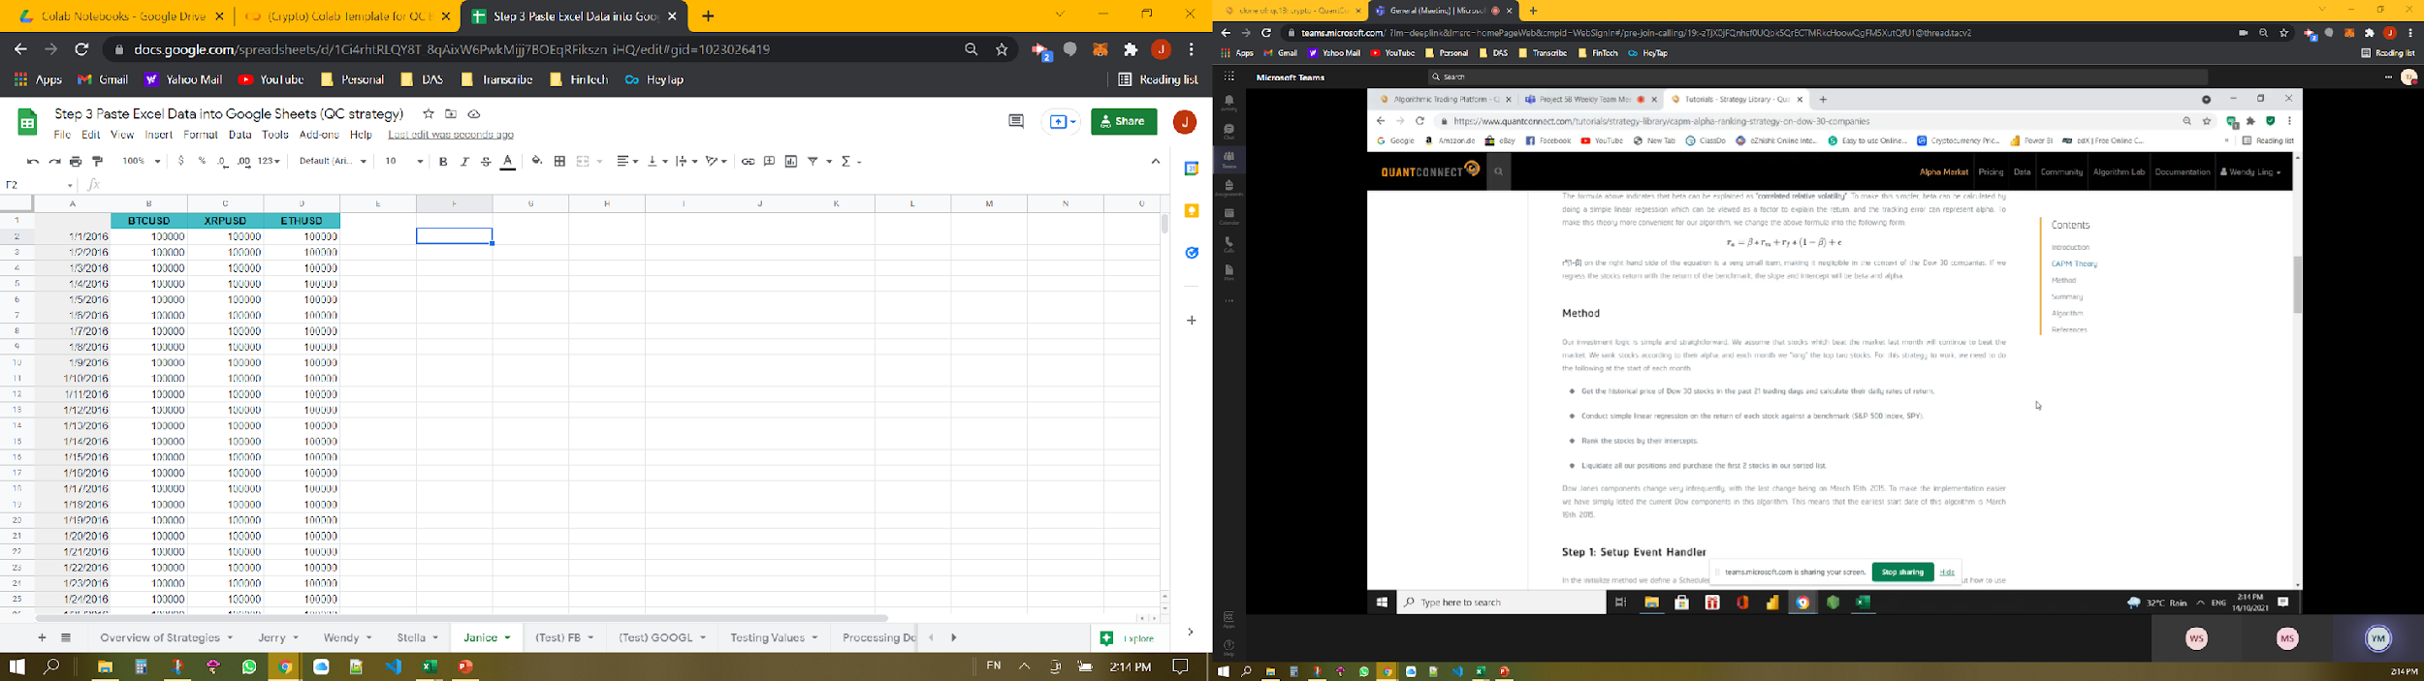

Step 5: Publish relevant tab to web **as CSV** for import into Google Colab

Go to “File” and select “Publish to the web”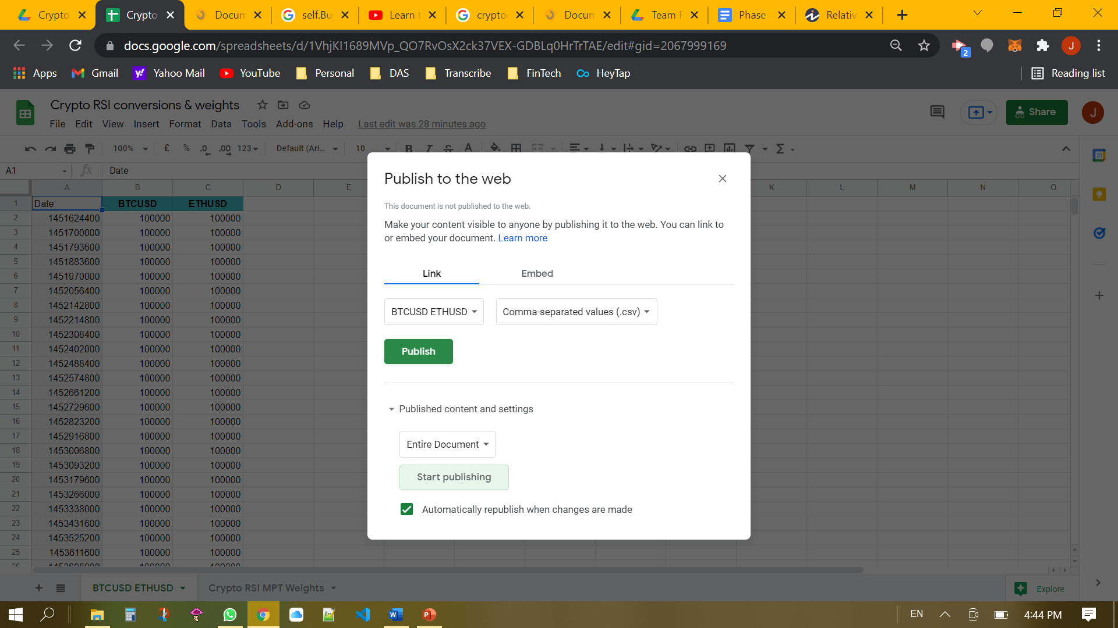

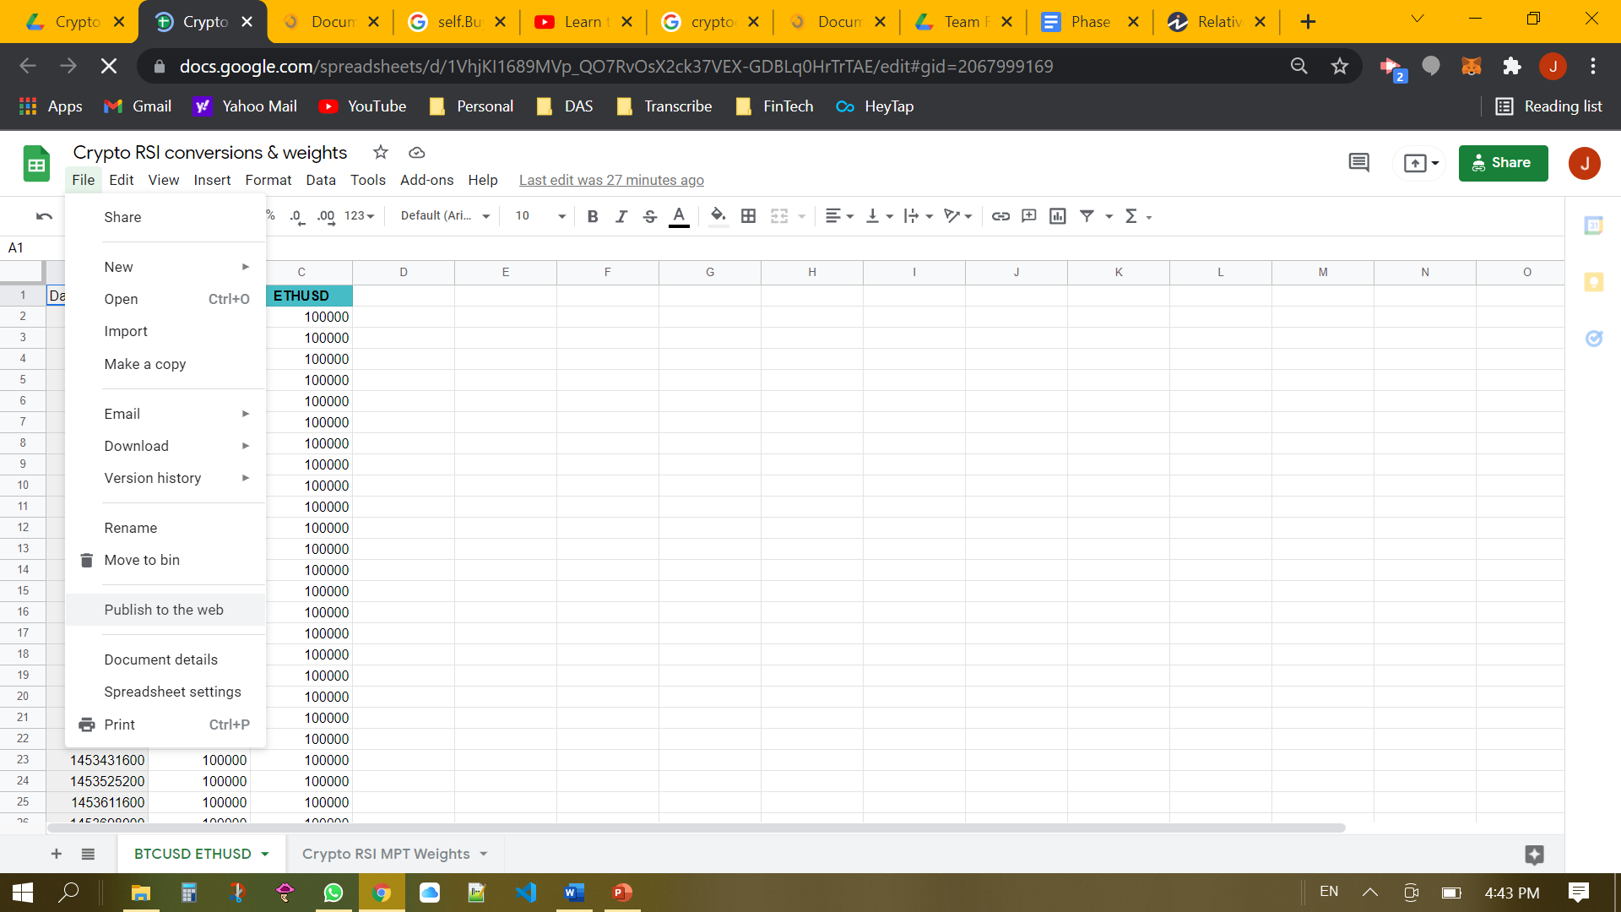 

#### 2.4 Google Colab

Step 1:Import libraries



Step 2: Import portfolio data from spreadsheet in Google Drive

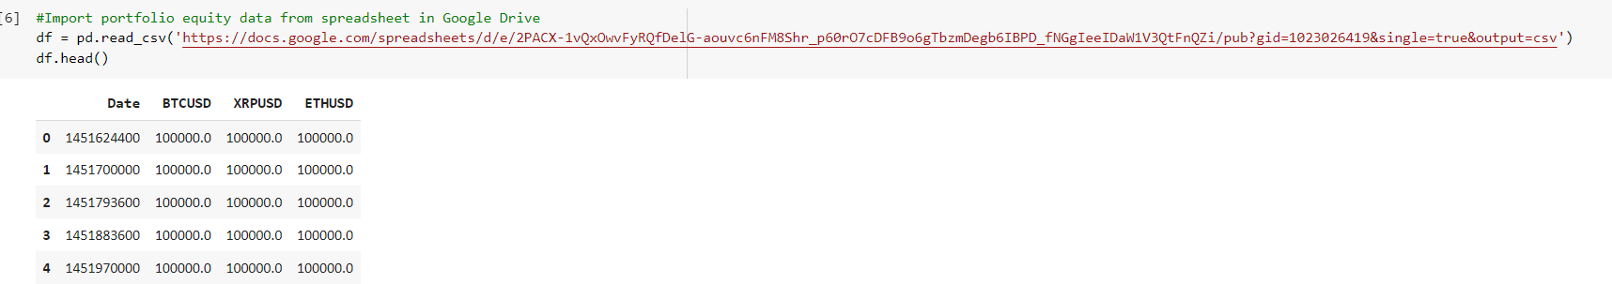

Step 3: Convert UNIX Timestamp to regular date format

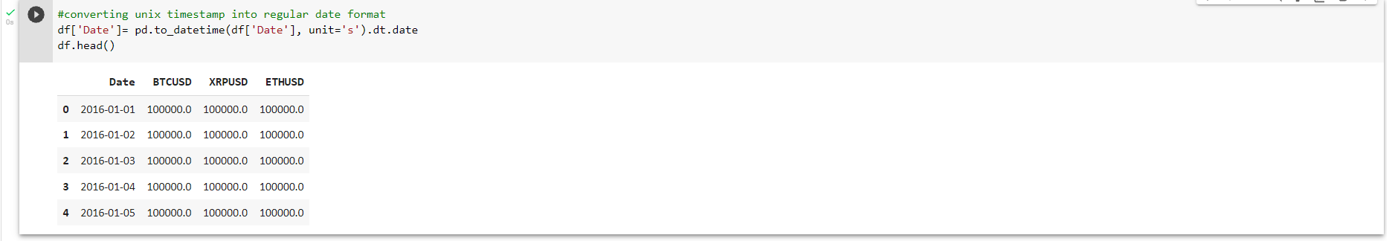

Step 4: Set index to ‘Date’ column

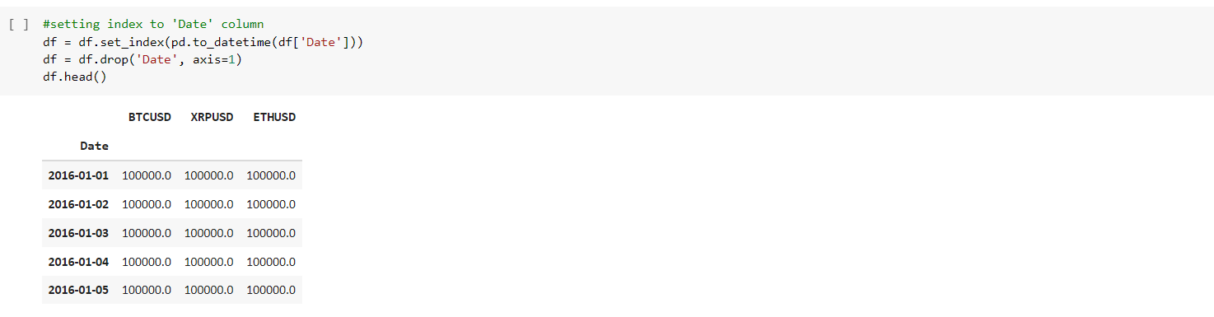

Step 5: Plot stock price graph

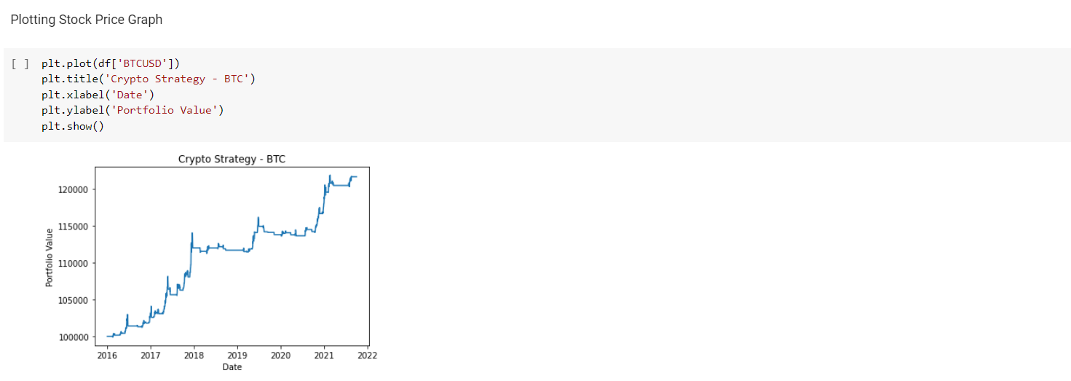

Step 6: Annual Returns and Volatility

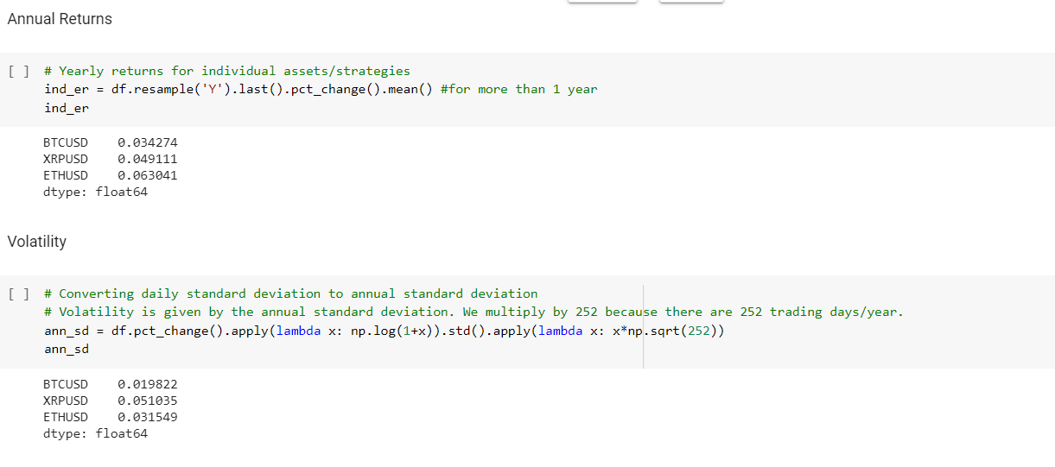

Step 7: Comparison of returns and volatility of assets

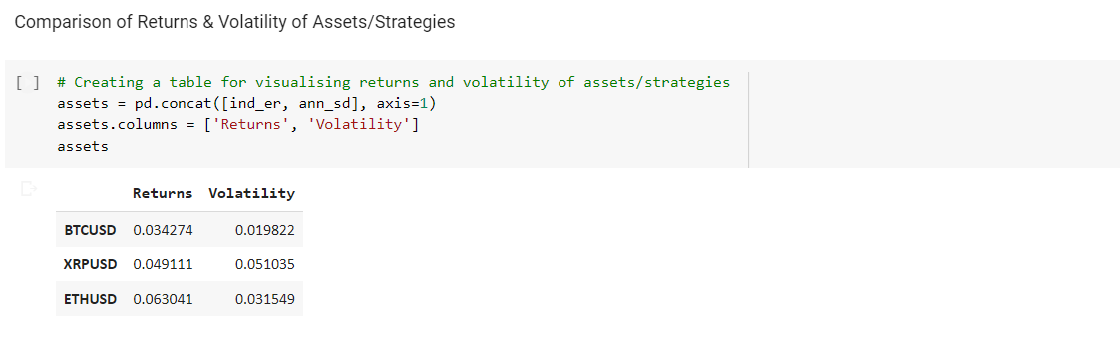

Step 8: Plotting Efficient Frontier

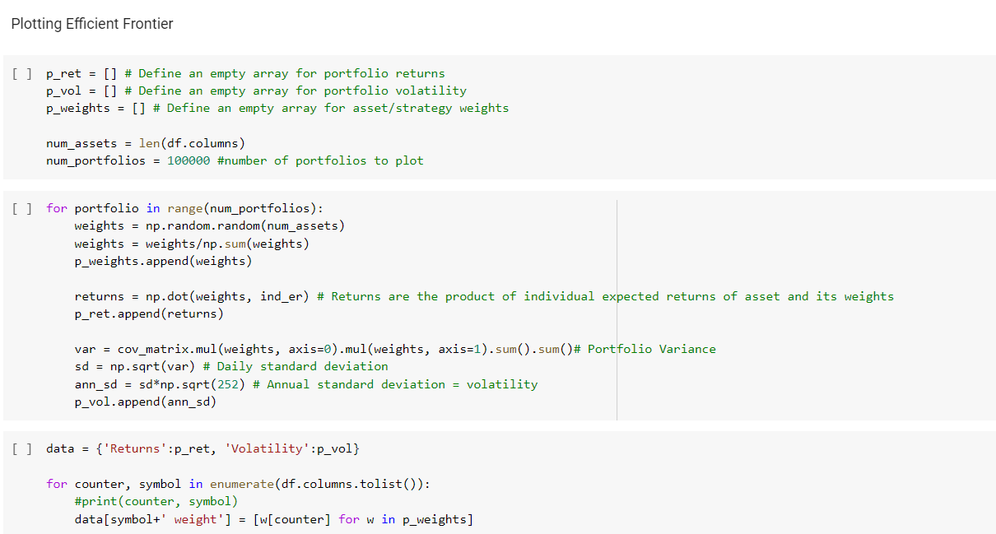

Step 9: Getting weights for lowest Volatility

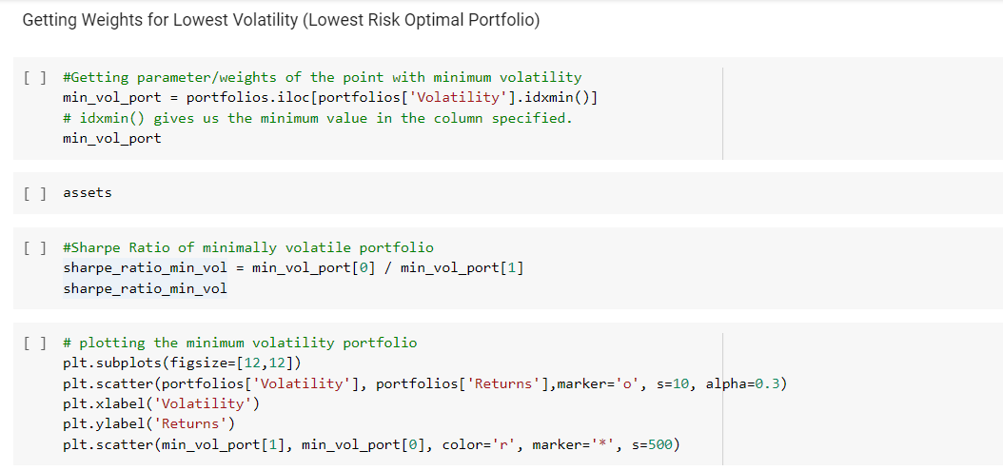

Step 10: Getting weights for highest Sharpe Ratio

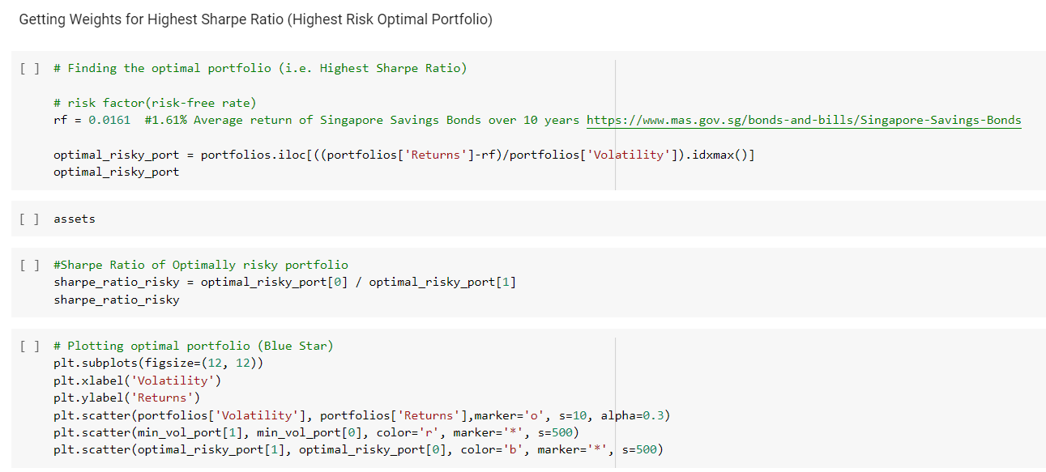

Step 11: Extract table data as CSV

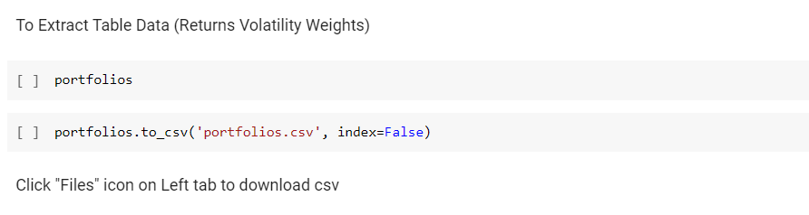

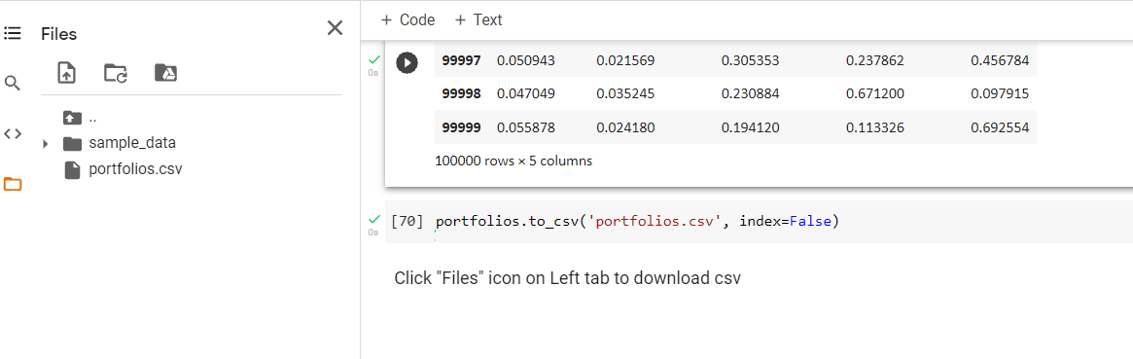

## 

# 3. Results & Findings

The table below summarizes the MPT allocated weightage of the different portfolio types.

| **Equities** | **Portfolio** | **Returns** | **Volatility** | **Weights** | | | | | |
| --- | --- | --- | --- | --- | --- | --- | --- | --- | --- |
| **AAPL** | **FB** | **GOOGL** | **MSFT** | **PG** | **SBUX** |
| High Sharpe Ratio | 0.058667 | 0.047013 | 0.334561 | 0.032007 | 0.002796 | 0.002687 | 0.503661 | 0.124289 |
| Low Volatility | 0.03978 | 0.033478 | 0.029422 | 0.098689 | 0.003956 | 0.033603 | 0.637509 | 0.19682 |
| **Crypto-**  **currency** | **Portfolio** | **Returns** | **Volatility** | **Weights** | |  | | | |
| **BTCUSD** | **ETHUSD** |
| High Sharpe Ratio | 0.05068 | 0.021403 | 0.42968 | 0.57032 |
| Low Volatility | 0.04103 | 0.018173 | 0.765161 | 0.234839 |

The table below summarizes the sharpe ratio, volatility, returns of the algo-trading strategies.

| **Portfolio Type** | **Returns** | **Volatility** | **Sharpe Ratio** |
| --- | --- | --- | --- |

| **Asset Momentum (Lowest Volatility)** | 1.39% | 0.244 | 0.136 |
| --- | --- | --- | --- |
| **Asset Momentum (Highest Sharpe Ratio)** | 70.25% | 0.142 | 1.142 |
| **CAPM (Lowest Volatility)** | 25.08% | 0.208 | 0.549 |
| **CAPM (Highest Sharpe Ratio)** | 31.29% | 0.222 | 0.628 |
| **Crypto RSI (Lowest Volatility)** | 27.25% | 0.075 | 1.326 |
| **Crypto RSI (Highest Sharpe Ratio)** | 15.94% | 0.046 | 1.363 |

**Phase 3 Documentation**

Integration of Algotrading & Power BI

# 1. Overview

Having developed and tested our trading strategies, we now set out to incorporate the backtested trading algorithms from Quantconnect into Power BI.

The visualization developed from this data will aim to help inform our users on the:

* Most appropriate algo trading strategy to deploy based on risk appetite
* Expected returns from their portfolio
* Volatility and Sharpe ratio of each proposed algorithm

To achieve this, our trading dashboard would be augmented with a Strategy view to highlight the above information.

# 2. Preparing the data

Following the backtest of each strategy in Quantconnect, the results have to be exported and converted from JSON into an excel readable CSV format, then imported into Power BI.

The following table relationships will then be established in Power BI.

| **From: Table (Column)** | **To: Table (Column)** | **Column Relationship** |
| --- | --- | --- |
| Strategy Summary | Strategy Graph | Type to Type |
| Strategy Summary | Stock Allocation | Type to Type |

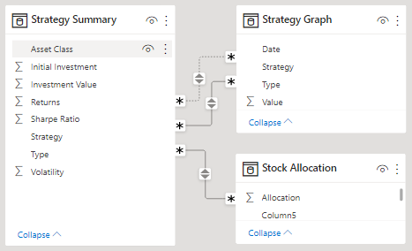

# 3. Creating the Strategy visualization

The Strategy visualization will highlight the performance of three different strategies with asset weightages optimized for either low volatility or high sharpe ratio.

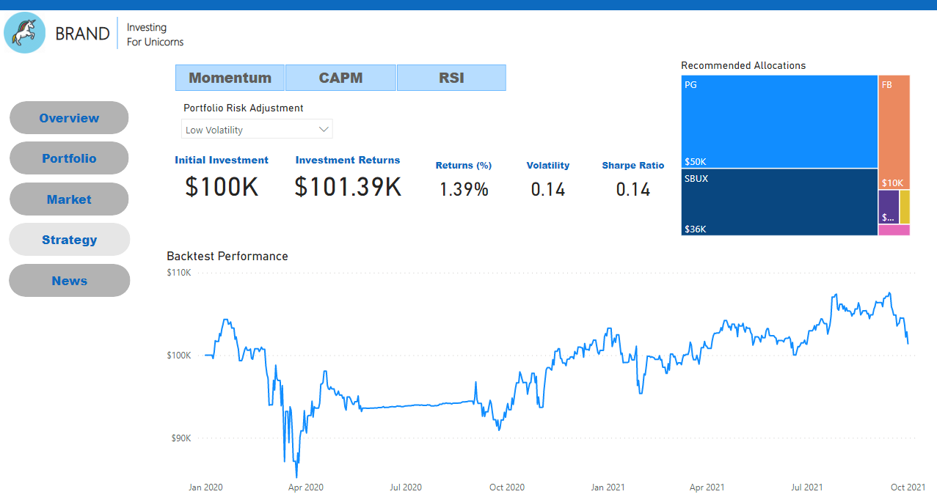

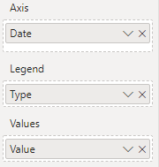

The strategy backtest data will be displayed on a line chart. To create the visual:

1. Select the **Report** icon found on the left side of Power BI Desktop
2. Navigate to the visualizations pane on the right and select the **Line Chart** visual
3. Drag the following data fields from the *Strategy Graph* table into the visualization inputs

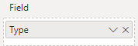

1. Navigate to the visualizations pane on the right and select the **Slicer** visual
2. Drag the following data fields from the *Strategy Graph* table into the visualization inputs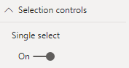
3. Format this visual to ensure **Single Select** is turned on under **Selection controls**

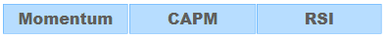

To allow users to view each strategy & investment approach independently, we will utilize buttons.

1. Insert three **blank** buttons & rename them

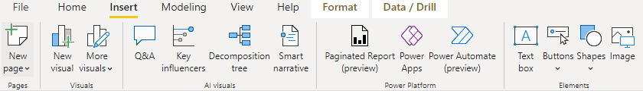

1. Next, navigate to **View** on the Power BI ribbon and select **Filters** and **Bookmarks**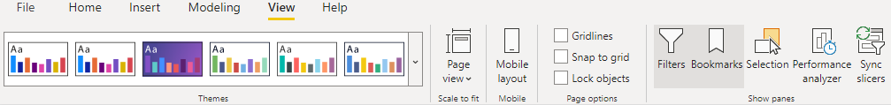
2. Within the **Filters** pane, add the following **Filters on this page**: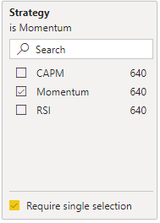

* Strategy Graph (Strategy)
* Strategy Summary (Strategy)
* Stock Allocation (Strategy)

1. Select **Momentum** strategy and check the Require single selection checkbox for each of the filters

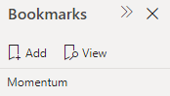

1. Within the Bookmarks pane, select **Add** to create a bookmarked view of these filters.
2. Rename each bookmark appropriately based on the filters applied.
3. Once complete, repeat steps 4 and steps 5 for the **CAPM** and **RSI** strategies by first applying them in the filters pane under **Filters on this page**, followed by creating a bookmark view.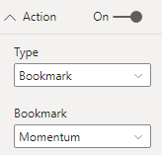
4. To initialize our buttons, select each and click on the **Format** button within the Visualization pane
5. Set the following for each button by linking them to the appropriate bookmark view.

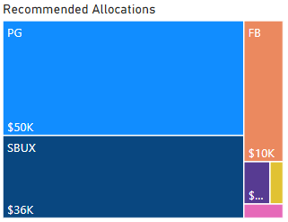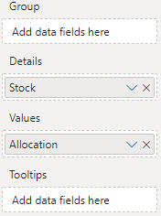

To create the recommended allocations visual:

1. Select the **Report** icon found on the left side of Power BI Desktop
2. Navigate to the visualizations pane on the right and select the **Treemap** visual
3. Drag the following data fields from the *Stock Allocation* table into the visualization inputs